# INTRODUCTION

This document will be updated with the notes made during class. The document will be made available in MS WORD format to allow students access to the Excel spreadsheets that were included during class. Please note that this document was compiled during class and was not proof read for typing, language, and calculation errors. Please inform the lecturer should you detect any serious errors.

# MOHR DIAGRAM AND DIRECTION OF STRESS

$$σ$$

$$τ$$

$$τ_{a}$$

$$σ_{1}$$

# GOODMAN MEAN STRESS CORRECTION

We calculate the equivalent completely reversed stress amplitude that represent the non-zero mean stress that was applied and can be used on the S-N curve.



$$\frac{σ_{a}}{σ_{ar}}+\frac{σ_{m}}{σ_{u}}=1 \\ σ_{ar}=\frac{σ_{a}}{1-\frac{σ_{m}}{σ_{u}}}$$

# STRESS-LIFE EXAMPLE DONE IN CLASS

## Problem statement

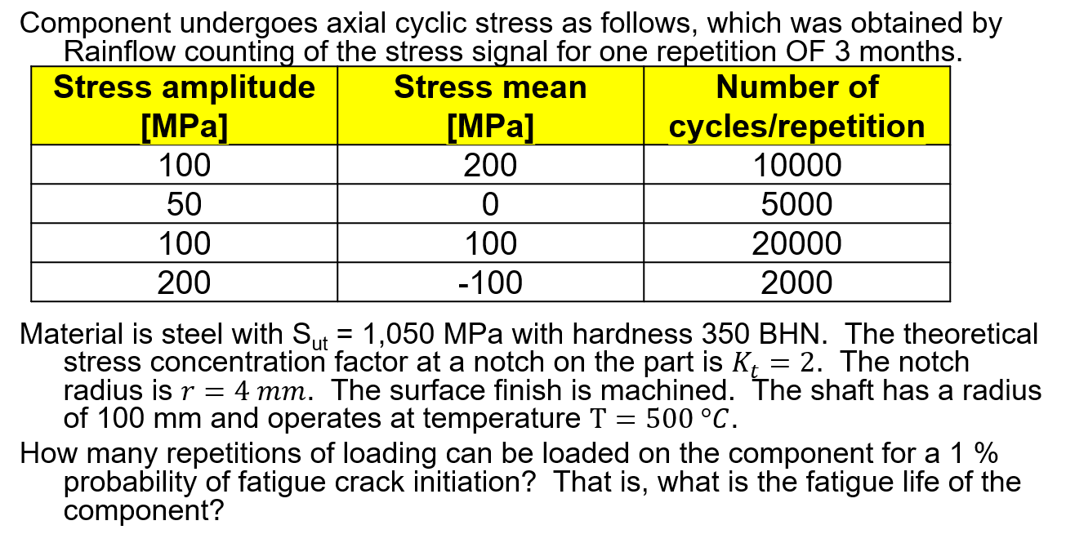

## Solution

Methodology:

1. Calculate my endurance limit, including modification factors, to see if there are any completely stress amplitudes that exceeds the endurance limit.
   1. Goodman mean stress correction.
   2. Calculate the modifying factors.
   3. Calculate the fatigue notch factor.
$$σ_{er}=σ_{erb}^{'}C_{size}C_{load}C_{surf}C_{T}C_{rel} \\ σ_{erb}^{'}=\frac{{0.5σ}_{u}}{K_{f}}$$

2. If the stress spectrum contains completely reversed stress amplitudes that exceed the endurance limit, construct the S-N curve.
$$σ_{ar,{10}^{3}}=σ_{arb,{10}^{3}}^{'}C_{load}C_{T}C_{rel} \\ σ_{arb,{10}^{3}}^{'}=\frac{0.9σ_{u}}{K_{f}^{'}}$$

3. Use Palmgren-Miner rule and calculate total damage.
4. Calculate number of repetitions and fatigue life.

### Fatigue notch factor at 1 million cycles, $K_{f}$

The theoretical stress concentration factor was given as $K_{t}=2$.

$$K_{f}=1+\frac{K_{t}-1}{\left(1+\frac{α}{r}\right)}$$

* Approximations for $α$:

$$α={\left[\frac{300}{σ_{u}\left[ksi\right]}\right]}^{1.8}×{10}^{-3} in. \\ ={\left[\frac{300×6.89}{1050}\right]}^{1.8}×{10}^{-3}×25.4 mm \\ =0.086 mm$$

From this, we have:



$$K_{f}=1+\frac{K_{t}-1}{\left(1+\frac{α}{r}\right)} \\ =1+\frac{2-1}{\left(1+\frac{0.086}{4}\right)} \\ =1.98$$

### Fatigue notch factor at 1 000 cycles, $K_{f}^{'}$

The ultimate tensile strength is 1050 MPa (=152 ksi). The notch sensitivity factor at 1 000 cycles is then $q=0.36$, from which:

$$\frac{K_{f}^{'}-1}{K_{f}-1}=q=0.36 \\ K_{f}^{'}=0.36\left(1.98-1\right)+1 \\ =1.35$$

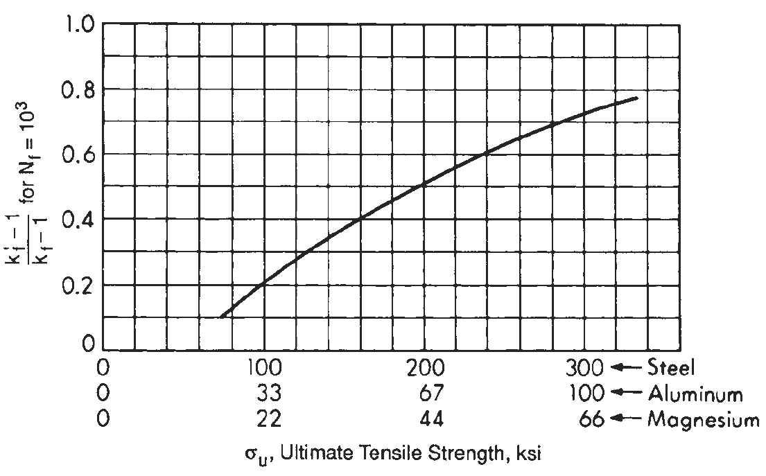

### Modification factor: Size, $C_{size}$

$$σ_{er}=σ_{erb}^{'}C_{size}C_{load}C_{surf}C_{T}C_{rel} \\ σ_{erb}^{'}=\frac{{0.5σ}_{u}}{K_{f}}$$

$$C_{size}=\left\{\begin{aligned}1.0, if d≤8 mm \\ 1.189d^{-0.097},if 8 mm<d≤250 mm\end{aligned}\right.$$

In this case, the diameter is 200 mm.

$$C_{siz}=1.189×{200}^{-0.097} \\ =0.71$$

### Modification factor: Load, $C_{load}$

The component will be subject to cyclic axial stress. The S-N curve that we will construct, will be from a rotating bending test. So, we have to do modification for load because of the larger volume that the axially loaded specimen will be subject to.

$$C_{load}=0.70$$

### Modification factor: Surface finish, $C_{surf}$

It is assumed that the machined surface is corrosion protected. Therefore, the modification factor for surface finish is $C_{surf}=0.70$:

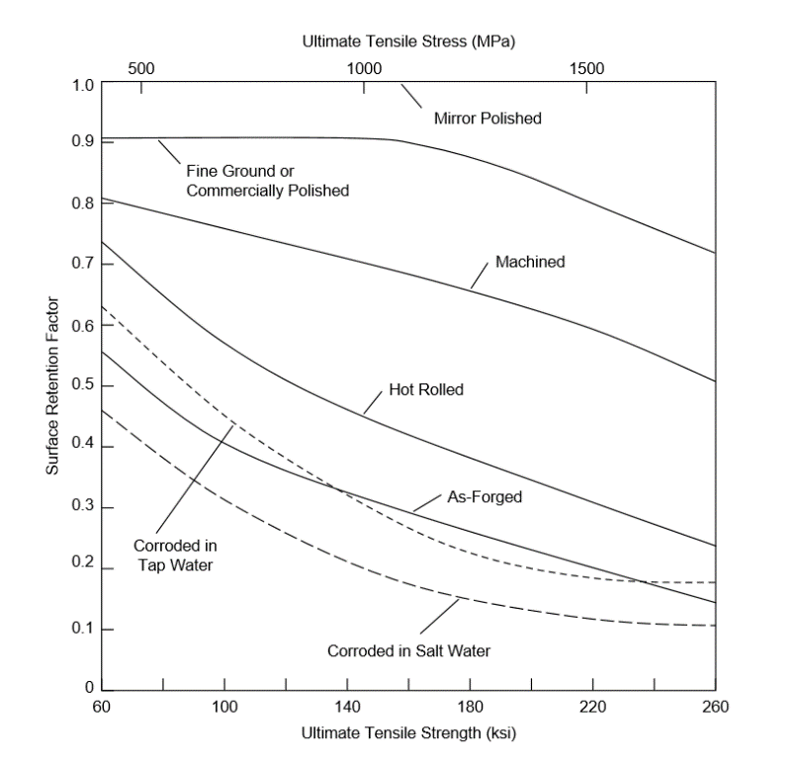

### Modification factor: Temperature, $C_{T}$

The component is subject to an operating temperature $T=500 ℃$. From this, the modification factor for temperature is:

$$C_{T}=\left\{\begin{matrix}1.0 for T≤450 ℃ \\ 1-{5.8}^{-3}\left(T-450\right), for 450<T≤550 ℃\end{matrix}\right. \\ =1-{5.8}^{-3}\left(500-450\right) \\ =0.74$$

### Modification factor: Reliability, $C_{rel}$

For a 1% probability of failure, we have a 99% probability of survival, and $C_{rel}=0.814$.

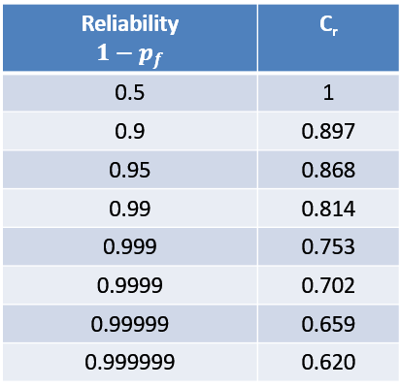

### Endurance limit after modification

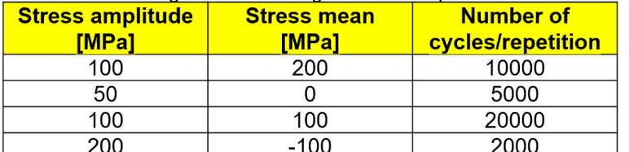The endurance limit after applying modification factors is 55.6 MPa, which is clearly below the stress amplitudes applied to the specimen (shown in the table below) and we need to construct the fatigue curve because we will have finite life in this case.

$$σ_{erb}^{'}=\frac{{0.5σ}_{u}}{K_{f}} \\ σ_{er}=σ_{erb}^{'}C_{size}C_{load}C_{surf}C_{T}C_{rel} \\ =\frac{0.5×1050}{1.98}∙0.71∙0.70∙0.70∙0.74∙0.814 \\ =55.6 MPa$$

### Construct the S-N curve

The fatigue strength at 1 000 cycles is:

$$σ_{arb,{10}^{3}}^{'}=\frac{0.9σ_{u}}{K_{f}^{'}} \\ σ_{ar,{10}^{3}}=σ_{arb,{10}^{3}}^{'}C_{load}C_{T}C_{rel} \\ =\frac{0.9∙1050}{1.35}∙0.7∙0.74∙0.814 \\ =295.2 MPa$$

For the part of the S-N curve below 295.2 MPa and above 55.6 MPa, the following applies:

$$S_{1}^{m}N_{1}=S_{2}^{m}N_{2} \\ m\log_{10}{\frac{S_{1}}{S_{2}}}=\log_{10}{\frac{N_{2}}{N_{1}}} \\ m=\frac{\log_{10}{\frac{N_{2}}{N_{1}}}}{\log_{10}{\frac{S_{1}}{S_{2}}}} \\ =\frac{\log_{10}{1000}}{\log_{10}{\frac{296.2}{55.6}}} \\ =4.13$$

### Goodman mean stress modification

$$σ_{ar}=\frac{σ_{a}}{1-\frac{σ_{m}}{σ_{u}}}$$

### Damage and life

For $\left[σ_{a},σ_{m}\right]=[100, 200]$ applied for $n=10 000 cycles$ we have:

* Goodman completely reversed stress amplitude is:
$$σ_{ar}=\frac{σ_{a}}{1-\frac{σ_{m}}{σ_{u}}} \\ =\frac{100}{1-\frac{200}{1050}} \\ =123.5 MPa$$

* The endurance is then:
$$N_{R}=\left\{\begin{matrix}{\left(\frac{σ_{ar,1}}{σ_{ar}}\right)}^{m}N_{1} & {0.9σ_{u}≥σ}_{ar}≥σ_{er} \\ ∞ & σ_{ar}<σ_{er}\end{matrix}\right. \\ =\left\{\begin{matrix}{\left(\frac{55.6}{σ_{ar}}\right)}^{4.13}{10}^{6} & {0.9σ_{u}≥σ}_{ar}≥σ_{er} \\ ∞ & σ_{ar}<σ_{er}\end{matrix}\right. \\ ={\left(\frac{55.6}{123.5}\right)}^{4.13}{10}^{6} \\ =35 818$$

* Damage:

$$d_{1}=\frac{10 000}{35 818} \\ =0.28$$

### Damage and life

For $\left[σ_{a},σ_{m}\right]=[50, 0]$ applied for $n=5 000 cycles$ we have:

* Goodman completely reversed stress amplitude is:
$$σ_{ar}=\frac{σ_{a}}{1-\frac{σ_{m}}{σ_{u}}} \\ =\frac{50}{1-\frac{0}{1050}} \\ =50 MPa$$

* The endurance is then:
$$N_{R}=\left\{\begin{matrix}{\left(\frac{σ_{ar,1}}{σ_{ar}}\right)}^{m}N_{1} & {0.9σ_{u}≥σ}_{ar}≥σ_{er} \\ ∞ & σ_{ar}<σ_{er}\end{matrix}\right. \\ =\left\{\begin{matrix}{\left(\frac{55.6}{σ_{ar}}\right)}^{4.13}{10}^{6} & {0.9σ_{u}≥σ}_{ar}≥σ_{er} \\ ∞ & σ_{ar}<σ_{er}\end{matrix}\right. \\ =∞$$

* Damage:

$$d_{2}=\frac{5 000}{∞} \\ =0$$

For $\left[σ_{a},σ_{m}\right]=[100, 100]$ applied for $n=20 000 cycles$ we have:

* Goodman completely reversed stress amplitude is:
$$σ_{ar}=\frac{σ_{a}}{1-\frac{σ_{m}}{σ_{u}}} \\ =\frac{100}{1-\frac{100}{1050}} \\ =110.5 MPa$$

* The endurance is then:
$$N_{R}=\left\{\begin{matrix}{\left(\frac{σ_{ar,1}}{σ_{ar}}\right)}^{m}N_{1} & {0.9σ_{u}≥σ}_{ar}≥σ_{er} \\ ∞ & σ_{ar}<σ_{er}\end{matrix}\right. \\ =\left\{\begin{matrix}{\left(\frac{55.6}{σ_{ar}}\right)}^{4.13}{10}^{6} & {0.9σ_{u}≥σ}_{ar}≥σ_{er} \\ ∞ & σ_{ar}<σ_{er}\end{matrix}\right. \\ ={\left(\frac{55.6}{110.5}\right)}^{4.13}{10}^{6} \\ =58 623 cycles$$

* Damage:

$$d_{3}=\frac{20 000}{58 623} \\ =0.34$$

For $\left[σ_{a},σ_{m}\right]=[200, -100]$ applied for $n=2 000 cycles$ we have:

* Goodman completely reversed stress amplitude is:
$$σ_{ar}=\frac{σ_{a}}{1-\frac{σ_{m}}{σ_{u}}} \\ =\frac{200}{1-\frac{-100}{1050}} \\ =182.6 MPa$$

* The endurance is then:
$$N_{R}=\left\{\begin{matrix}{\left(\frac{σ_{ar,1}}{σ_{ar}}\right)}^{m}N_{1} & {0.9σ_{u}≥σ}_{ar}≥σ_{er} \\ ∞ & σ_{ar}<σ_{er}\end{matrix}\right. \\ =\left\{\begin{matrix}{\left(\frac{55.6}{σ_{ar}}\right)}^{4.13}{10}^{6} & {0.9σ_{u}≥σ}_{ar}≥σ_{er} \\ ∞ & σ_{ar}<σ_{er}\end{matrix}\right. \\ ={\left(\frac{55.6}{182.6}\right)}^{4.13}{10}^{6} \\ =7 364 cycles$$

* Damage:

$$d_{4}=\frac{2 000}{7 364} \\ =0.27$$

The total damage is then:

$$D=d_{1}+d_{2}+d_{3}+d_{4} \\ =0.28+0+0.34+0.27 \\ =0.89$$

The number of repetitions of the 3-month stress spectrum is:

$$B_{f}=\frac{1}{D} \\ =1.12$$

The fatigue life for this component for a 1% probability of failure is:

$$L=Period of stress spectrum×B_{f} \\ =\frac{Period of stress spectrum}{D} \\ =3×1.12 \\ =3.36 months$$

# PROBLEM 2019-08-14: STRESS LIFE CLASS PROBLEM

## Problem statement

Component undergoes axial cyclic stress as follows:

|  |  |  |
| --- | --- | --- |
| **Stress amplitude**  **[MPa]** | **Stress mean**  **[MPa]** | **Number of cycles/block** |
| 100 | 200 | 10000 |
| 50 | 0 | 5000 |
| 100 | 100 | 20000 |
| 200 | -100 | 2000 |

Material is steel with Sut = 1,050MPa with hardness 350 BHN. The theoretical stress concentration factor at a notch on the part is . The notch radius is . The surface finish is machined. The shaft has a radius of 100 mm and operates at temperature

How many blocks of loading can be loaded on the component for a 1 % probability of fatigue crack initiation? That is, what is the fatigue life of the component?

## Solution

Step 1: Construct the S-N curve for the material

We need the following:

$$S_{{10}^{3}}=\frac{0.9f_{u}}{K_{f}^{'}}C_{load}C_{rel}C_{T}, at N={10}^{3}cycles$$

$$S_{e}=\frac{0.5f_{u}}{K_{f}}C_{load}C_{rel}C_{T}C_{size}C_{surf}, at N={10}^{6}$$

Step 2: Calculate the influencing factors

**Fatigue notch factor**

The fatigue notch factor at endurance, $K_{f}$, is as follows:

$$K_{f}=1+\frac{K_{t}-1}{\left(1+\frac{a}{r}\right)} \\ a={\left[\frac{300}{σ_{u}\left[ksi\right]}\right]}^{1.8}×{10}^{-3} in. \\ ={\left[\frac{300}{\frac{1050}{6.89}}\right]}^{1.8}×{10}^{-3}×25.4 mm \\ =0.0859 mm \\ K_{f}=1.98$$

The notch fatigue factor at 1 000 cycles, $K_{f}^{'}$, is then:

$$\frac{K_{f}^{'}-1}{K_{f}-1}=f\left(σ_{u}\right)=q$$

From the figure below at ultimate tensile strength $\frac{1 050}{6.89}\sim 150 ksi$, the fatigue notch sensitivity factor (from the figure below) is:

$$q=0.4$$

From this:

$$\frac{K_{f}^{'}-1}{K_{f}-1}=q \\ K_{f}^{'}=q\left(K_{f}-1\right)+1 \\ =1.39$$

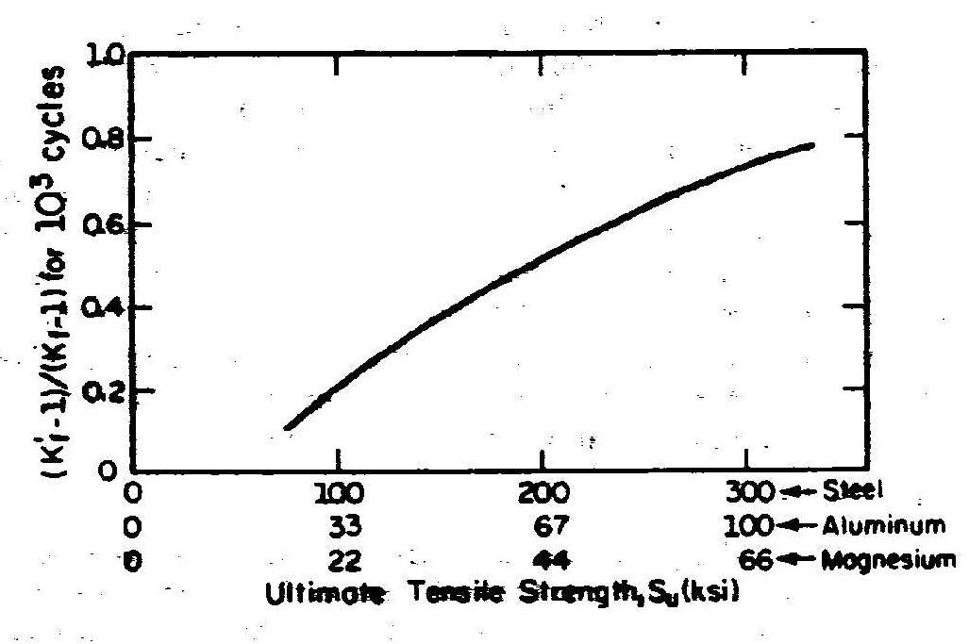

**Modification factor: Load**

For axial loading, the load factor is:

$$C_{load}=0.7$$

**Modification factor: Reliability**

The client requested a 1% probability of crack initiation, which is a 99% probability6 of survival.

From the table below, the modification factor for reliability is:



$$C_{rel}=0.814$$

**Modification factor: Temperature**

The operating temperature was given as $T=200 °C$. Therefore, the modification factor is:

$$C_{T}=\left\{\begin{matrix}1.0 for T≤450 ℃ \\ 1-{5.8}^{-3}\left(T-450\right), for 450<T≤550 ℃\end{matrix}\right. \\ =1.0$$

**Modification factor: Size**

The shaft diameter is 200 mm. Therefore, the modification factor for size is:

$$C_{size}=\left\{\begin{aligned}1.0, if d≤8 mm \\ 1.189d^{-0.097},if 8 mm<d≤250 mm\end{aligned}\right. \\ =1.189×{0.2}^{-0.097} \\ =0.71$$

**Modification factor: Surface finish**

From the graph, $C_{surf}=0.7$



Step 4: Formula for the S-N curve

The S-N curve is modeled by the following function:

$$σ_{ar,1}N_{1}^{b}=σ_{ar,2}N_{2}^{b} \\ {\left(\frac{N_{1}}{N_{2}}\right)}^{b}=\frac{σ_{ar,2}}{σ_{ar,1}} \\ b=\frac{\left(\log_{10}{\frac{σ_{ar,2}}{σ_{ar,1}}}\right)}{\log_{10}{\frac{N_{1}}{N_{2}}}}$$

The endurance at any completely reversed stress amplitude is then:

$$N_{R}=\left\{\begin{matrix}{\left(\frac{σ_{ar,1}}{σ_{ar}}\right)}^{\frac{1}{b}}N_{1} & {0.9f_{u}≥σ}_{ar}≥S_{e} \\ ∞ & σ_{ar}<S_{e}\end{matrix}\right.$$

For mean stress correction, Goodman was applied to calculate the equivalent completely reversed stress amplitude, $σ_{ar}$ from stress value with amplitude, $σ_{a}$, mean $σ_{m}$ as follows:

$$\frac{σ_{a}}{σ_{ar}}+\frac{σ_{m}}{f_{u}}=1 \\ σ_{ar}=\frac{σ_{a}}{1-\frac{σ_{m}}{f_{u}}}$$

These were programmed in the excel sheet below, from which the number of repetitions to failure is $B_{f}=$



# CLASS PROBLEM ON 2019-10-07

## Problem statement

The flange of a welded steel girder is classified as Detail category 125 according to BS EN 1993-1-9. The component is subject to 500 000 cycles for stress range 200 MPa. Adopt a safe life strategy with low consequence of failure. The partial factor for equivalent constant amplitude stress range is $γ_{Ff}=1.0$. Is this design acceptable?

## Solution

Given is the following:

$$Δσ_{C}=125 MPa \\ N_{C}=2×{10}^{6}cycles$$

We need to modify this fatigue strength for temperature, post-weld treatment, corrosion, design philosophy, etc. From the information given, we have only the design method.

Partial factor for fatigue

Specified is a safe life assessment method with low consequence of failure, for which $γ_{Mf}=1.15$.

|  |  |  |
| --- | --- | --- |
| **Assessment method** | **Consequence of failure** | |
| **Low consequence** | **High consequence** |
| Damage tolerant | 1.00 | 1.15 |
| Safe life | 1.15 | 1.35 |
| Source: BS EN 1993-1-9, 2005:11 | | |

Parameters on the SR-N curve

The reduced characteristic fatigue strength is:

$$Δσ_{C,red}=\frac{Δσ_{C}}{γ_{Mf}}$$

The constant amplitude fatigue limit is (no information was given on the SR-N curve slope, and it was assumed 3):

$$Δσ_{D}^{m_{1}}N_{D}={\left(\frac{Δσ_{C}}{γ_{Mf}}\right)}^{m_{1}}N_{C} \\ Δσ_{D}=\left(\frac{Δσ_{C}}{γ_{Mf}}\right){\left(\frac{N_{C}}{N_{D}}\right)}^{\frac{1}{m_{1}}} \\ =\left(\frac{125}{1.15}\right){\left(\frac{2}{5}\right)}^{\frac{1}{3}} \\ =80 MPa$$

The stress range applied of 200 MPa, exceeds the constant amplitude fatigue limit, and, we have finite life.

To calculate endurance from S-N curve

The endurance on the SR-N curve is given as follows:

$$Δσ_{R}^{m_{1}}N_{R}=Δσ_{D}^{m_{1}}N_{D}, for 1.5f_{y}>Δσ_{R}≤Δσ_{D} \\ Δσ_{R}^{m_{2}}N_{R}=Δσ_{D}^{m_{2}}N_{D}, for Δσ_{D}>Δσ_{R}≤Δσ_{L}$$ Below $Δσ_{L}$ we have infinite life.

The endurance can now be calculated as follows:

$$N_{R}=\left\{\begin{matrix}{\left(\frac{Δσ_{D}}{Δσ_{R}}\right)}^{m_{1}}N_{D} & 1.5f_{y}>Δσ_{R}≤Δσ_{D} \\ {\left(\frac{Δσ_{D}}{Δσ_{R}}\right)}^{m_{2}}N_{D} & Δσ_{D}>Δσ_{R}≤Δσ_{L} \\ ∞ & Δσ_{R}<Δσ_{L}\end{matrix}\right.$$

Apply to the problem

**For $Δσ_{R}=200 MPa$ and $N_{R}=500 000$ cycles, the damage is:**

* In this case the stress range is above the constant amplitude fatigue limit – finite life.
* The endurance at the supplied stress range is:
$$N_{R}=\left\{\begin{matrix}{\left(\frac{Δσ_{D}}{Δσ_{R}}\right)}^{m_{1}}N_{D} & 1.5f_{y}>Δσ_{R}≤Δσ_{D} \\ {\left(\frac{Δσ_{D}}{Δσ_{R}}\right)}^{m_{2}}N_{D} & Δσ_{D}>Δσ_{R}≤Δσ_{L} \\ ∞ & Δσ_{R}<Δσ_{L}\end{matrix}\right. \\ ={\left(\frac{80}{200}\right)}^{3}5×{10}^{6} \\ =321 000 cycles$$

* The damage caused is: $d_{1}=\frac{n_{1}}{N_{1}}=\frac{500000}{321000}=1.56$, this is larger than one, and we have failure.

The design is not sufficient.

# CLASS PROBLEM 2

## Problem statement

The fatigue performance of a welded detail in a steel linkspan structure can be represented by a fatigue curve corresponding to BS EN 1993-1-9 Detail Category 36. The linkspan carries typical vehicles of weight 1, 2 and 5 ton. A linear elastic finite beam element analysis revealed the stress ranges in the welded detail as summarised in the table on the right with the proportion of vehicles carried by the ferry 70%, 28% and 2% respectively as summarised in the table. The linkspan is used twice per day. No more than one vehicle can occupy the linkspan at any one time. The design life required is equal to the service life of 40 years. Is this design sufficient if a damage tolerant with high consequence of failure strategy is implemented? A total of 50 vehicles are carried per day, and two stress cycles are caused to the linkspan per vehicle (on- and off loading).



## Solution

Partial factor for fatigue

Specified is a damage tolerant assessment method with high consequence of failure, for which $γ_{Mf}=1.15$.

|  |  |  |
| --- | --- | --- |
| **Assessment method** | **Consequence of failure** | |
| **Low consequence** | **High consequence** |
| Damage tolerant | 1.00 | 1.15 |
| Safe life | 1.15 | 1.35 |
| Source: BS EN 1993-1-9, 2005:11 | | |

Detail category fatigue curve

The problem specifies the fatigue curve as detail category $36$. Therefore, the unmodified fatigue strength at 2 000 000 cycles is 36 MPa. We need to modify this value for modification factors and partial factor for fatigue.

Corrosive environment

Nothing is mentioned, it will be assumed that the linkspan is properly surface protected.

Modification factors

Nothing is mentioned about temperature and post-weld treatments, so all these factors will be excluded.

$$C_{T}=1 \\ C_{PWT}=1$$

Constant amplitude fatigue limit

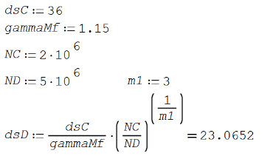The constant amplitude fatigue limit in this case is:

$$Δσ_{D}=\frac{Δσ_{C}}{γ_{Mf}}{\left(\frac{N_{C}}{N_{D}}\right)}^{{\frac{1}{m}}_{1}} \\ =23 MPa$$

There are stress ranges exceeding the constant amplitude fatigue limit, and therefore, we have finite life.

Cut-off limit

There are stress ranges below the constant amplitude fatigue limit, and therefore, the cut-off limit is required for calculation of endurance on this part of the curve. The cut-off limit is:

$$Δσ_{L}=Δσ_{D}{\left(\frac{N_{D}}{N_{L}}\right)}^{\frac{1}{m_{2}}} \\ =13 MPa$$

Equation for endurance at any stress range

The endurance for corrosion protected or non-corrosive environment, is given as:

$$N_{R}=\left\{\begin{matrix}{\left(\frac{Δσ_{D}}{Δσ_{R}}\right)}^{m_{1}}N_{D} & 1.5f_{y}>Δσ_{R}≤Δσ_{D} \\ {\left(\frac{Δσ_{D}}{Δσ_{R}}\right)}^{m_{2}}N_{D} & Δσ_{D}>Δσ_{R}≤Δσ_{L} \\ ∞ & Δσ_{R}<Δσ_{L}\end{matrix}\right.$$

Apply to the problem

**For $Δσ_{R1}=20 MPa$ and $n_{1}=1 022 000$ cycles, the damage is:**

The endurance is:

$$N_{R}=\left\{\begin{matrix}{\left(\frac{Δσ_{D}}{Δσ_{R}}\right)}^{m_{1}}N_{D} & 1.5f_{y}>Δσ_{R}≤Δσ_{D} \\ {\left(\frac{Δσ_{D}}{Δσ_{R}}\right)}^{m_{2}}N_{D} & Δσ_{D}>Δσ_{R}≤Δσ_{L} \\ ∞ & Δσ_{R}<Δσ_{L}\end{matrix}\right. \\ ={\left(\frac{23}{20}\right)}^{5}5 000 000 \\ =10 200 000 cycles$$

The damage is then:

$$d_{1}=\frac{n_{1}}{N_{R1}} \\ =\frac{1 022 000}{10 200 000} \\ =0.10$$

**For $Δσ_{R2}=30 MPa$ and $n_{2}=408 800$ cycles, the damage is:**

The endurance is:

$$N_{R}=\left\{\begin{matrix}{\left(\frac{Δσ_{D}}{Δσ_{R}}\right)}^{m_{1}}N_{D} & 1.5f_{y}>Δσ_{R}≤Δσ_{D} \\ {\left(\frac{Δσ_{D}}{Δσ_{R}}\right)}^{m_{2}}N_{D} & Δσ_{D}>Δσ_{R}≤Δσ_{L} \\ ∞ & Δσ_{R}<Δσ_{L}\end{matrix}\right. \\ ={\left(\frac{23}{30}\right)}^{3}5 000 000 \\ =2 272 400 cycles$$

The damage is then:

$$d_{2}=\frac{n_{1}}{N_{R1}} \\ =\frac{408800}{2 272 400} \\ =0.18$$

**For $Δσ_{R3}=40 MPa$ and $n_{3}=29 200$ cycles, the damage is:**

The endurance is:

$$N_{R}=\left\{\begin{matrix}{\left(\frac{Δσ_{D}}{Δσ_{R}}\right)}^{m_{1}}N_{D} & 1.5f_{y}>Δσ_{R}≤Δσ_{D} \\ {\left(\frac{Δσ_{D}}{Δσ_{R}}\right)}^{m_{2}}N_{D} & Δσ_{D}>Δσ_{R}≤Δσ_{L} \\ ∞ & Δσ_{R}<Δσ_{L}\end{matrix}\right. \\ ={\left(\frac{23}{40}\right)}^{3}5 000 000 \\ =958 660 cycles$$

The damage is then:

$$d_{3}=\frac{n_{3}}{N_{R3}} \\ =\frac{29 200}{958 660} \\ =0.0305$$

The total damage is then:

$$D=\sum{d_{i}} \\ =0.10+0.18+0.03 \\ =0.3106$$

The total damage is less than one and the design is sufficient.

Number of repetitions

The number of repetitions of the stress spectrum is:

$$B_{f}=\frac{1}{D} \\ =3.22$$

Total design life

The design life of the linkspan is $Period×B_{f}=\frac{Period}{D}=3.22×40=129 years$

# CLASS PROBLEM ON 2019-10-08

## Problem statement

* A fabricator of a pressure vessel elected to use as 25.4 mm plate made of:
  + Specify the material
* The radius should be 500 mm
* Determine the allowable working pressure of the cylindrical section of the pressure vessel
* Corrosion Allowance:
  + Make provision for 3.2 mm for corrosion

## Problem statement

In this case the shell thickness was prescribed. Requested is the allowable working pressure of the cylindrical section of the pressure vessel.

Our approach can be as follows:

1. Find the maximum allowable stress, $S$, for a plate material that include the thickness given.
2. Calculate the internal diameter after corrosion occurred: $D=2×500+2×3.2=$
3. Calculate the allowable working pressure

Material properties

From the material data sheet shown below, the material in Line 36 was chosen, it is plate product and covers the thickness range required as well as the operating temperature. From this, the maximum allowable stress is:

$$S=103 MPa$$

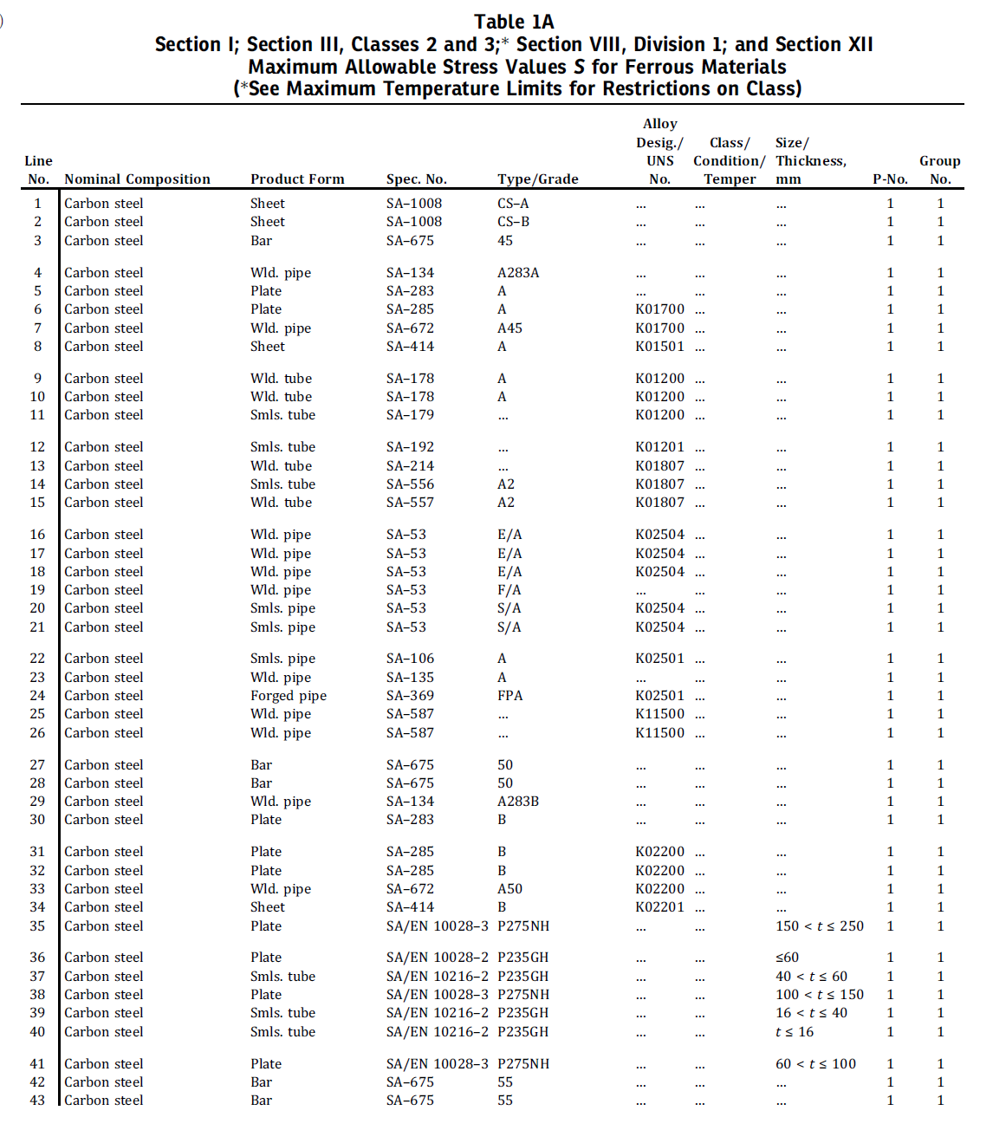

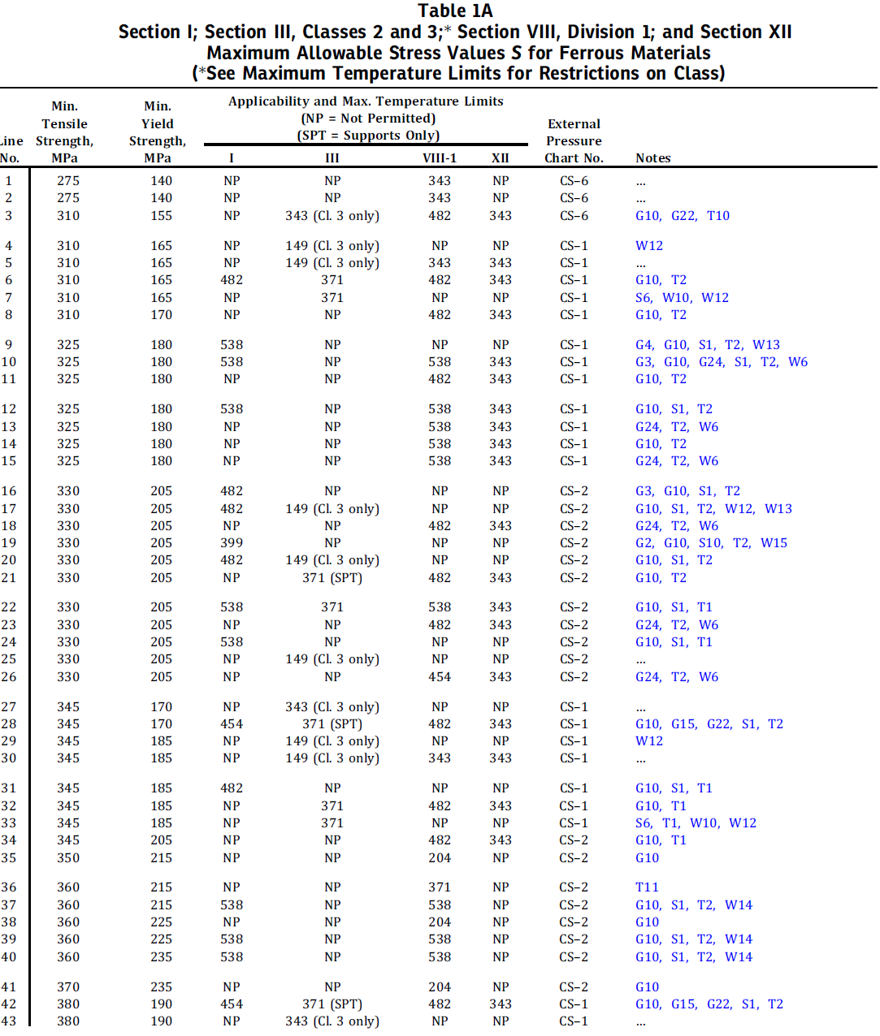

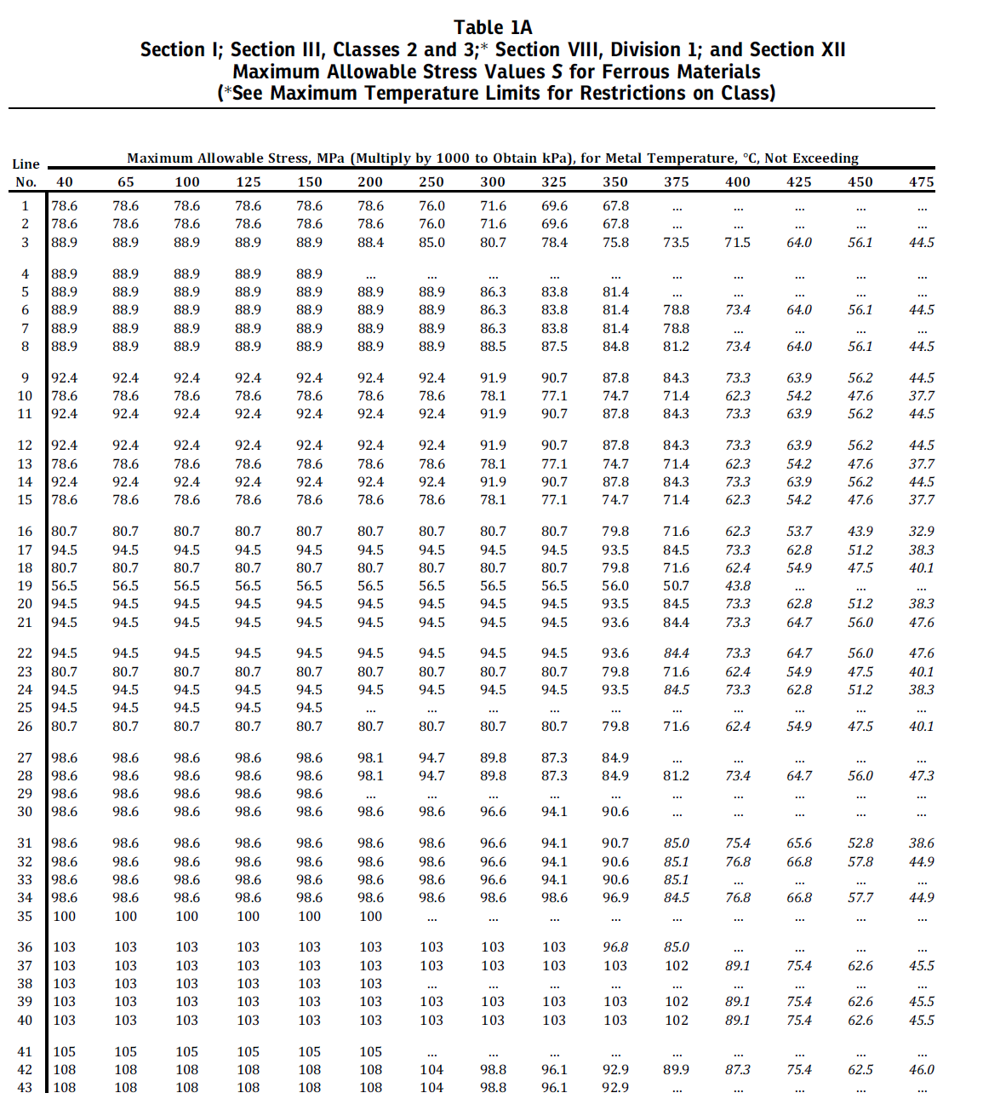

Joint efficiency

In the absence of information on the weld quality control, it was decided to design the vessel as if made by single welded butt joints with backing strip with the limitations show in the Column3 of the table below. The vessel will further be designed as no radiographic examination is done after completion of the welds. For this, the joint efficiency is:

$$E=0.65$$

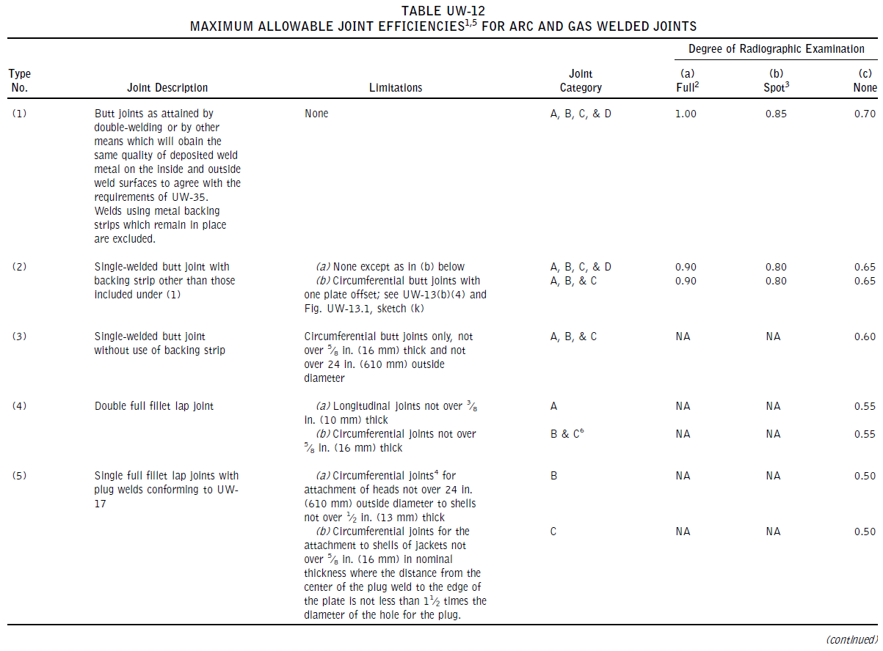

Calculate allowable working pressure

For a cylindrcal vessel under internal pressure, the maximum working pressure can be calculated by:

$$P=\frac{SEt}{r+0.6t} \\ =\frac{103×0.65×(0.0254-0.0032)}{\left(0.5+0.0032\right)+0.6×(0.0254-0.0032)} \\ =2.9 MPa$$

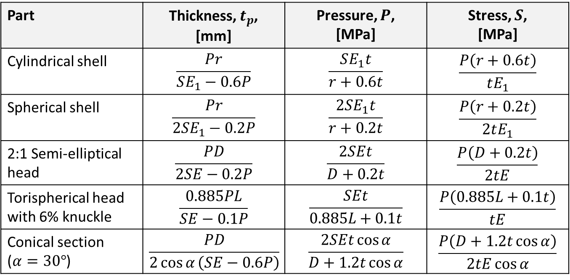

What will be the pressure be during the hydrostatic test at 1.3P:

$$σ=\frac{P\left(r+0.6t\right)}{tE} \\ =\frac{1.3×2.9\left(0.5+0.0032+0.6\left(0.0254-0.0032\right)\right)}{\left(0.0254-0.0032\right)×0.65} \\ =134 MPa$$

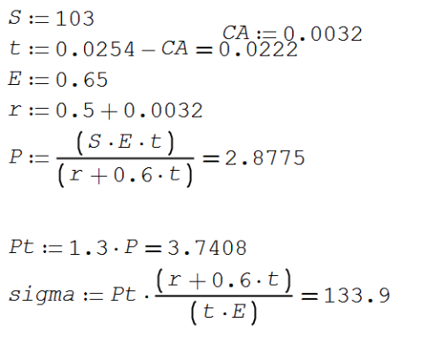

# THE REST OF THE PROBLEMS ARE FROM PREVIOUS LECTURES ON THE TOPIC YOUR CLASSNOTES WILL BE UPDATED AFTER THE SECOND CLASS DAY

# S-N CURVE EXAMPLE

## Problem statement

Construct the S-N curve for a material with completely reversed stress amplitude $σ_{ar1}=500 MPa$ at $N_{f1}={10}^{3}$ cycles and endurance limit $σ_{er}=150 MPa$ at $N_{fe}={10}^{6}$ cycles. Then, calculate the endurance for the following completely reversed stress amplitudes: 300 MPa, 200 MPa, and, 100 MPa.

## Solution

The equation for the S-N curve is assumed to be: $σ=AN_{f}^{b}$.

Therefore:

$$A=\frac{σ}{N_{f}^{b}} \\ =σN_{f}^{-b} \\ σ_{ar1}N_{f1}^{-b}=σ_{ar2}N_{f2}^{-b} \\ {\left(\frac{N_{f1}}{N_{f2}}\right)}^{-b}=\frac{σ_{ar2}}{σ_{ar1}} \\ b=-\frac{\log_{10}{\frac{σ_{ar2}}{σ_{ar1}}}}{\log_{10}{\frac{N_{f1}}{N_{f2}}}} \\ =-0.1743$$

Say I need to calculate the endurance (fatigue life) at any stress amplitude, the equation becomes:

$${\left(\frac{N_{f1}}{N_{f2}}\right)}^{-b}=\frac{σ_{ar2}}{σ_{ar1}} \\ \frac{N_{f1}}{N_{f2}}={\left(\frac{σ_{ar2}}{σ_{ar1}}\right)}^{-\frac{1}{b}} \\ N_{fi}=\left\{N_{fe}\begin{matrix}{\left(\frac{σ_{er}}{σ_{ari}}\right)}^{-\frac{1}{b}} & σ_{a{r10}^{3}}≥σ_{ari}≥σ_{er} \\ ∞ & σ_{ari}<σ_{er}\end{matrix}\right.$$

The other option is to find the equation for the S-N curve in the form $σ_{ar}^{m}N=C$. For this, we use the points provided:

$$σ_{ar1}^{m}N_{f1}=σ_{ar2}^{m}N_{f2} \\ {\left(\frac{σ_{ar1}}{σ_{ar2}}\right)}^{m}=\frac{N_{f2}}{N_{f1}} \\ m=\frac{\log_{10}{\frac{N_{f2}}{N_{f1}}}}{\log_{10}{\frac{σ_{ar1}}{σ_{ar2}} }}$$

In this case, the endurance at any stress is then:

$$N_{fi}=\left\{N_{fe}\begin{matrix}{\left(\frac{σ_{er}}{σ_{ari}}\right)}^{m} & σ_{a{r10}^{3}}≥σ_{ari}≥σ_{er} \\ ∞ & σ_{ari}<σ_{er}\end{matrix}\right.$$

From which it is clear that



$$m=-\frac{1}{b}$$

# RAINFLOW COUNTING

The explanation that was done in class.

Table 1: Rainflow counted stress spectrum over a period of 1 year

|  |  |  |  |
| --- | --- | --- | --- |
| $$σ_{a}$$ | $$σ_{m}$$ | $$Δσ$$ | $$n$$ |
| 45 | 35 | 90 | 0.5+0.5=1 |
| 90 | 10 | 180 | 0.5+0.5=1 |
| 25 | 25 | 50 | 0.5+0.5=1 |
| 35 | 25 | 70 | 0.5+0.5=1 |



(100;-80;180)

(80;-10;90)

(60;-10;70)

(50;0;50)

(-10;60;70)

(0;50;50)

(-80;100;180)

(-10;80;90)

Figure 1: Stress signal over a period of 1 year

# BENDING MOMENT DISTRIBUTION

## Principle

Steps to calculate the bending moment at any position $x$:

1. At position $x$, formulate the bending moments by just looking towards the origin of the coordinate system.
   1. For $x∈[0;a]$:
 $$M_{y}=M_{R_{A}}+M_{w} \\ =R_{A}x-wx∙\frac{x}{2}$$

  2. For $x∈[A;L]$:

$$M_{y}=M_{R_{A}}+M_{w} \\ =R_{A}x-wa∙\left(x-\frac{a}{2}\right)$$

$$w$$

$$R_{A}$$

$$x$$

z

$$\frac{x}{2}$$

$$a$$

## Example

Consider the beam loaded in the -z direction with force 100 kN and constrained at Points A, B and C as shown in the figure below. The bending moment distribution is also shown below. From the bending moment distribution, if possible, the best point for splicing is where the bending moment is zero.

Point A

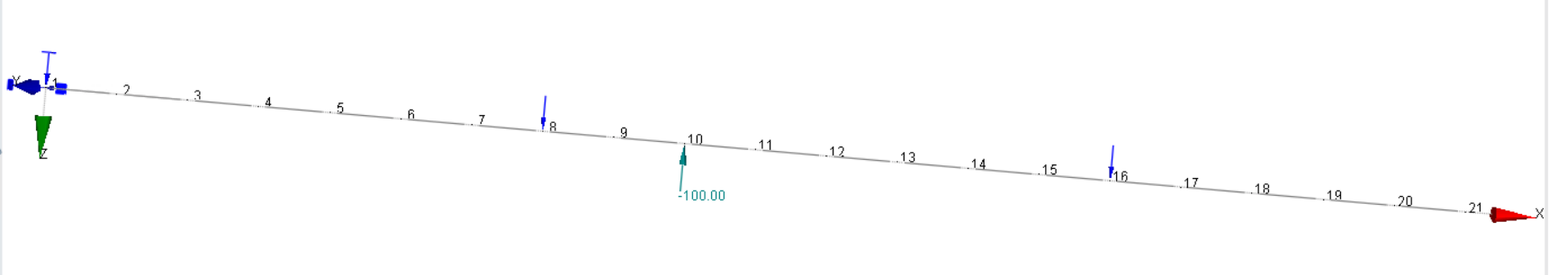

Point C

Point B

Figure 2: Bending moment diagram

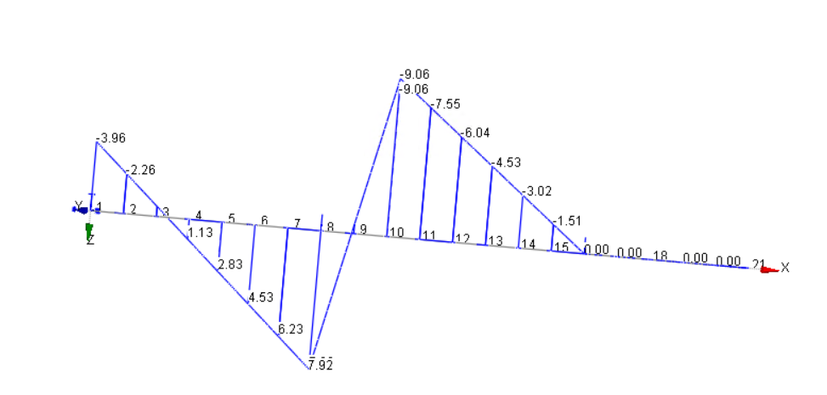

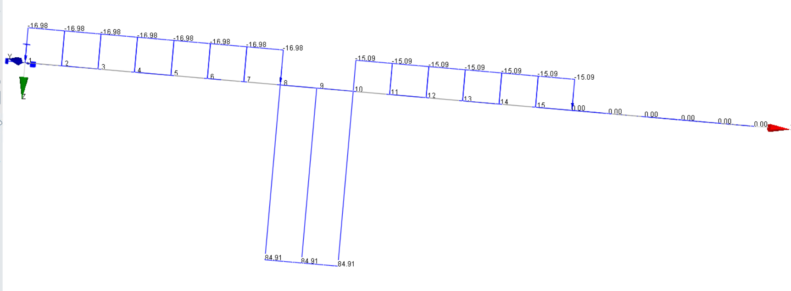

Figure 3: Shear force diagram

# BENDING STRESS DISTRIBUTION

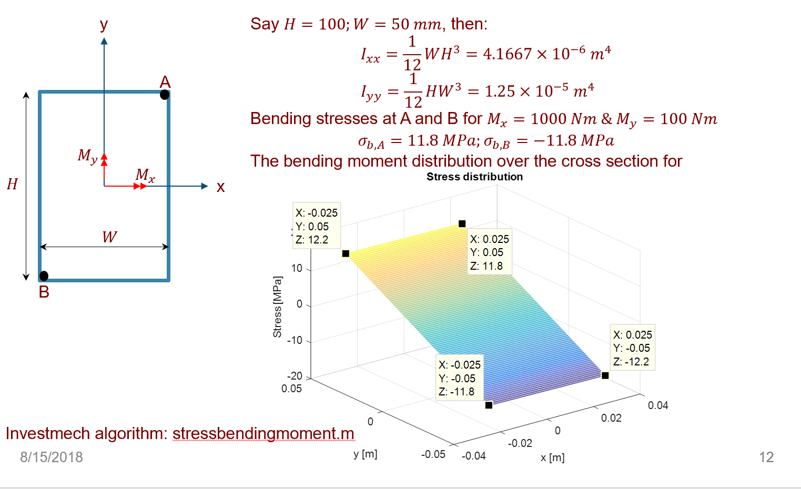

The bending stress distribution is given by:

$$σ_{b,i}=\frac{M_{x}y_{i}}{I_{xx}}-\frac{M_{y}x_{i}}{I_{yy}}$$ The second moment of area for this problem is:

$$I_{xx}=\frac{1}{12}WH^{3};I_{yy}=\frac{1}{12}HW^{3}$$

For Point A:



$$σ_{b,i}=\frac{\frac{M_{x}H}{2}}{\frac{1}{12}WH^{3}}-\frac{\frac{M_{y}W}{2}}{\frac{1}{12}HW^{3}} \\ =\frac{6M_{x}}{WH^{2}}-\frac{6M_{y}}{HW^{2}}$$

If a tensile force is also applied, the stress at any point is given by:

$$σ_{n}=\frac{F}{A}$$

Say a force of 1 kN is applied, what is the stress at point A?



# MEAN STRESS CORRECTION

## Problem Statement

Check sensitivity for the completely reversed bending stress amplitude, $σ_{ar}$, for the mean stress of a signal using the following mean stress correction relationships:

* Modified Goodman
* Gerber
* Smith, Watson & Topper (WST)
* Walker

Assume a material ultimate tensile strength $σ_{u}=700 MPa$ and consider the following stress states:

|  |  |
| --- | --- |
| **Stress amplitude**  **[MPa]** | **Stress mean**  **[MPa]** |
| 100 | -100 |
| 100 | 0 |
| 100 | 100 |

## Solution

From the notes, the relevant equations are:

|  |  |
| --- | --- |
| **Approach** | **Equations** |
| Modified Goodman | $$σ_{ar}=\frac{σ_{a}}{1-\frac{σ_{m}}{σ_{u}}}$$ |
| Gerber | $$σ_{ar}=\frac{σ_{a}}{1-{\left(\frac{σ_{m}}{σ_{u}}\right)}^{2}}, for σ_{m}≥0$$ |
| SWT | $$σ_{ar}=\sqrt{σ_{max}σ_{a}} \\ =σ_{max}\sqrt{\frac{1-R}{2}}$$ |
| Walker | $$σ_{ar}=σ_{max}^{1-γ}σ_{a}^{γ} \left(σ_{max}>0\right) \\ =σ_{max}{\left(\frac{1-R}{2}\right)}^{γ} \left(σ_{max}>0\right)$$ $$γ=\begin{matrix}-0.000200σ_{u}+0.8818 & (σ_{u} in MPa)\end{matrix}$$ |

Programmed in Excel, the results are as shown in the table below. Can you explain and make recommendations? See your text book.



# S-N CURVE STRESS LIFE EXAMPLE

## Problem statement

300WA structural steel has the following material properties:

*E* = 206 GPa, *fy* = 300MPa,

*fut* =450MPa

Assume a notch fatigue factor of $k_{f}=1.7$

What is the endurance limit $P_{surv}=0.5$?

How many cycles to failure at

1. $σ_{ar1}$ = 200MPa
2. $σ_{ar2}$ = 300MPa

## Solution

Step 1: Define the equation for the S-N curve

In this case the yield strength is below 700 MPa, and we will assume that the S-N curve need to be modified for a notch fatigue factor at 1 000 cycles. For the general unmodified, unnotched material, the S-N curve has the following two points:

$$σ_{ar1}^{m}N_{1}=σ_{ar2}^{m}N_{2} \\ σ_{ar{10}^{3}}^{m}{10}^{3}=σ_{er}^{m}{10}^{6}$$ However, we need to modify the S-N curve for the notch by the following factors:

$$K_{f}=1+\frac{K_{t}-1}{1+\frac{a}{r}}=1.7$$

The notch fatigue factor at 1 000 cycles, $K_{f}'$ is determined as $K_{f}^{'}=1$ as shown below.



For $S_{ut}=64 ksi$, $\frac{K_{f}^{'}-1}{K_{f}-1}=0$, therefore, $K_{f}^{'}=1$

Figure 4: Calculation of notch fatigue factor at 1 000 cycles

The limits on the S-N curve, modified for the notch, is:

$$σ_{er}=\frac{0.5σ_{ut}}{K_{f}} \\ =\frac{0.5×450}{1.7} \\ =132 MPa \\ σ_{ar{10}^{3}}=0.9σ_{ut} \\ =405 MPa$$

The equation for the S-N curve is now:



$$N_{R}=\left\{\begin{matrix}{\left(\frac{σ_{er}}{σ_{arR}}\right)}^{m}N_{e} & for σ_{arR}≥σ_{er} \\ ∞ & for σ_{arR}<σ_{er}\end{matrix}\right.$$

Figure 5: S-N curve for the notched specimen

The exponent (slope), $m$ is:

$$σ_{er}^{m}N_{e}=σ_{ar{10}^{3}}^{m}∙{10}^{3} \\ {\left(\frac{σ_{er}}{σ_{ar{10}^{3}}}\right)}^{m}=\frac{{10}^{3}}{{10}^{6}} \\ m\log_{10}{\frac{σ_{er}}{σ_{ar{10}^{3}}}}=-3 \\ m=-\frac{3}{\log_{10}{\frac{σ_{er}}{σ_{ar{10}^{3}}}}} \\ =6.18$$

Step 2: Calculate endurance at requested stress amplitudes

1. For $σ_{ar1}=200 MPa$ (larger than $σ_{er}$), the endurance is:
$$N_{1}={\left(\frac{σ_{er}}{σ_{ar1}}\right)}^{m}N_{e} \\ ={\left(\frac{132}{200}\right)}^{6.18}∙{10}^{6} \\ =78 090 cycles$$

2. For $σ_{ar2}=300 MPa$ (larger than $σ_{er}$), the endurance is:

$$N_{2}={\left(\frac{σ_{er}}{σ_{ar2}}\right)}^{m}N_{e} \\ ={\left(\frac{132}{300}\right)}^{6.18}∙{10}^{6} \\ =6 382 cycles$$

Step 3: General remarks

If all the stress amplitudes where endurance was required are below the endurance limit, you do not need to model the S-N curve, because, the answer is infinite life.

# STRESS LIFE EXAMPLE WITH MEAN STRESS CORRECTION

## Problem statement

Component undergoes cyclic stress with:

σmax = 770MPa

σmin = 70MPa

Material is steel with $σ_{u}$ = 1,050MPa and $σ_{er}$ = 420MPa. The fully reversed stress at $σ_{ar{10}^{3}}$ = 770 MPa.

How many cycles can be loaded on the component until fatigue crack initiation? That is, what is the fatigue life of the component?

## Solution

### Calculate stresses and compare with endurance limit

The stress amplitude is: $σ_{a}=\frac{\left(770-70\right)}{2}=350 MPa$

The mean stress is: $σ_{m}=\frac{770+70}{2}=420 MPa$

Do mean stress correction. Use Goodman:

$$\frac{σ_{a}}{σ_{ar}}+\frac{σ_{m}}{σ_{ut}}=1 \\ σ_{ar}=\frac{σ_{a}}{1-\frac{σ_{m}}{σ_{ut}}} \\ =\frac{350}{1-\frac{420}{1050}} \\ =583 MPa$$ The Goodman mean stress corrected equivalent completely reversed stress amplitude is $σ_{ar}=583≥420 MPa$, therefore, we have finite life and the S-N curve must be calculated.

### S-N curve

The S-N curve is given as:

$$N_{R}=\left\{\begin{matrix}{\left(\frac{σ_{er}}{σ_{arR}}\right)}^{m}N_{e} & for σ_{arR}≥σ_{er} \\ ∞ & for σ_{arR}<σ_{er}\end{matrix}\right.$$

For which:

$$σ_{ar{10}^{3}}^{m}∙{10}^{3}=σ_{er}^{m}∙{10}^{6} \\ m=\frac{\log_{10}\left(\frac{{10}^{3}}{{10}^{6}}\right)}{\log_{10}{\frac{σ_{er}}{σ_{ar{10}^{3}}}}} \\ =11.4$$

### Calculate endurance at specified stress amplitude

$σ_{ar}=583 MPa$ is larger than the endurance limit $σ_{er}=420 MPa$. For this completely reversed stress amplitude, the endurance is the:

$$N_{R}={\left(\frac{σ_{er}}{σ_{arR}}\right)}^{m}N_{er} \\ ={\left(\frac{420}{583}\right)}^{11.64}∙{10}^{6} \\ =23 820 cycles$$

# FATIGUE: STRESS LIFE CALCULATION

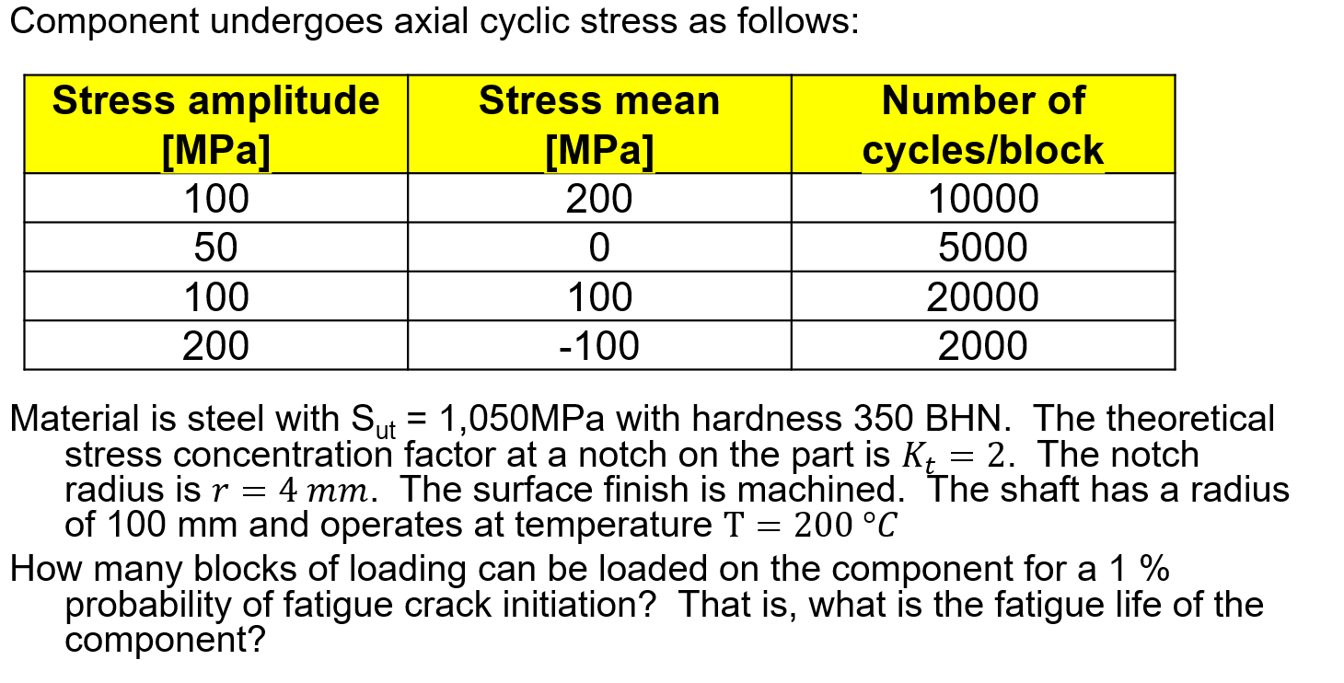

## Solution

### Construct the S-N curve

From what we know, the fatigue strength of a mirror polished specimen subject to completely reversed bending, is as follows at 1 000 and 1 000 000 cycles:

$$σ_{{10}^{3}}=0.9σ_{u} \\ σ_{er}=0.5σ_{u}$$

This is for 50% probability of crack initiation in endurance $N$

$$σ_{er}=C_{size}C_{load}C_{surf}C_{T}C_{rel}σ_{erb} \\ C_{e}=C_{size}C_{load}C_{surf}C_{T}C_{rel} \\ S_{er}=\frac{σ_{er}}{k_{f}} \\ =\frac{C_{e}σ_{u}}{k_{f}} \\ S_{{10}^{3}}=S_{{10}^{3}}^{'}C_{load}C_{T}C_{rel}$$

Modification factor: Notch

The fatigue notch factor at the endurance, or fatigue, limit is (note, this is at 1 000 000 cycles):

$$q=\frac{1}{1+\frac{α}{ρ}} \\ k_{f}=1+\frac{k_{t}-1}{\left(1+\frac{α}{ρ}\right)} \\ α={\left[\frac{300}{f_{u}\left[ksi\right]}\right]}^{1.8}×{10}^{-3} in.$$

The fatigue notch factor at 1 000 000 cycles was calculated in the Excel sheet as $K_{f}=1.98$.

Fatigue notch factor at 1 000 cycles:

|  |  |  |  |
| --- | --- | --- | --- |
| $$q=\frac{K_{f}^{'}-1}{K_{f}-1}=f\left(f_{ut}\right) \\ K_{f}^{'}=q\left(K_{f}-1\right)+1 \\ =1.39$$ | ( | 51 | ) |



Figure : Ration between notch fatigue factors at 1 000 and 1M cycles vs tensile strength

$$Modification factor:size$$

The modification factor for size was calculated from the following equation as 0.71 for the shaft with diameter 200 mm:

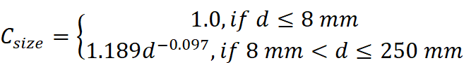

Modification factor: Load

The S-N curve was defined from a rotating bending test approach. The loading is axial, and therefore, $C_{load}=0.7$.

Modification factor: surface

For the machined condition, $C_{surface}=0.7$

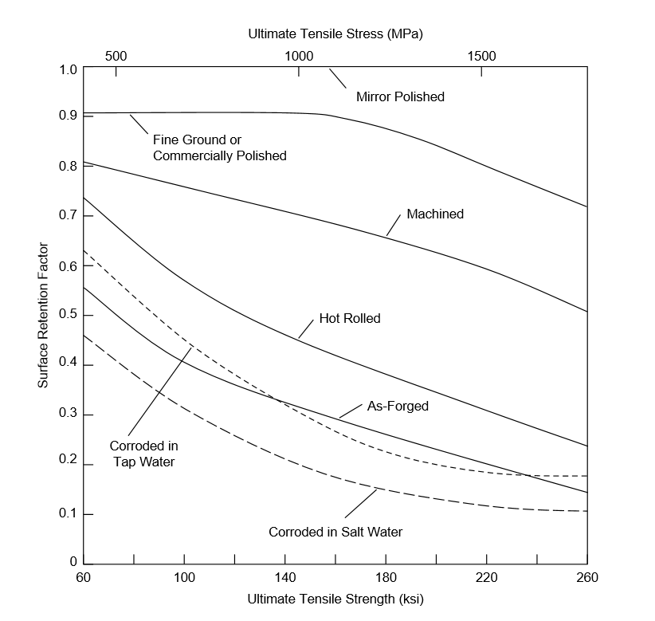

Modification factor: Temperature

The machine operates at 200 °C, where $C_{T}=1.0$

$$C_{T}=\begin{matrix}1.0 for T≤450 ℃ \\ 1-{5.8}^{-3}\left(T-450\right), for 450<T≤550 ℃\end{matrix}$$

Modification factor: Reliability

The S-N curve derived above, is for 50% probability of crack initiation (or survival). The design requires a 1% probability of crack initiation (or 99% probability of survival). From the table below, $C_{rel}=0.814$ to achieve a probability of survival of 1% in N.



### Equation for the S-N curve

The S-N curve is modelled by the following function:

$$σ=AN_{f}^{b}$$ For which we have the following:

$$S_{er}=AN_{e}^{b"} \\ =A{10}^{6b} \\ S_{{10}^{3}}=AN_{3}^{b} \\ =A{10}^{3b}$$

To solve:

$$\frac{S_{er}}{S_{{10}^{3}}}=\frac{AN_{e}^{b"}}{AN_{3}^{b}} \\ ={\left(\frac{N_{e}}{N_{3}}\right)}^{b} \\ b=\frac{\log_{10}{\frac{S_{er}}{S_{{10}^{3}}}}}{\log_{10}{\frac{N_{e}}{N_{3}}}} \\ A=\frac{S_{er}}{N_{e}^{b}}$$

The endurance at any completely reversed stress amplitude, can be calculated as follows:

$$N_{i}=\left\{\begin{matrix}{\left(\frac{σ_{ar}}{A}\right)}^{\frac{1}{b}} & for σ_{ar}≥S_{er} \\ ∞ & for σ_{ar}<S_{er}\end{matrix}\right.$$

### Mean-stress compensation

The stress history has non-zero means. Mean stress compensation using: Goodman, Morrow, SWT, Walker.

For Goodman: we already have ultimate strength.

For Morrow: Need $σ_{f}$, which is equal to $A$ in this case, or, if the material was specified, it can be determined from the material data sheet.

For Walker, we need $γ=\begin{matrix}-0.000200σ_{u}+0.8818 & (σ_{u} in MPa)\end{matrix}$

|  |  |
| --- | --- |
| **Approach** | **Equations** |
| Modified Goodman | $$σ_{ar}=\frac{σ_{a}}{1-\frac{σ_{m}}{σ_{u}}}$$ |
| Gerber | $$σ_{ar}=\frac{σ_{a}}{1-{\left(\frac{σ_{m}}{σ_{u}}\right)}^{2}}, for σ_{m}≥0$$ |
| SWT | $$σ_{ar}=\sqrt{σ_{max}σ_{a}} \\ =σ_{max}\sqrt{\frac{1-R}{2}}$$ |
| Walker | $$σ_{ar}=σ_{max}^{1-γ}σ_{a}^{γ} \left(σ_{max}>0\right) \\ =σ_{max}{\left(\frac{1-R}{2}\right)}^{γ} \left(σ_{max}>0\right)$$ $$γ=\begin{matrix}-0.000200σ_{u}+0.8818 & (σ_{u} in MPa)\end{matrix}$$ |

# STRAIN-LIFE EXAMPLE WITH STRAIN INPUTS

## Problem statement

The cyclic stress-strain and strain-life parameters for a steel is:

E=30 x 103 ksi; K’ = 154 ksi, σ’f = 133ksi, ε’f = 0.26, n’ = 0.202, b = -0.095,

c=-0.47

Determine the life for the histories shown on the next slide (use Morrow).

## Solution

The equations needed:

Ramberg-Osgood: $ε=\frac{σ}{E}+{\left(\frac{σ}{H^{'}}\right)}^{\frac{1}{n^{'}}}$

Strain-life equation: $ε=\frac{σ_{f}^{'}}{E}{\left(2N_{f}\right)}^{b}+ε_{f}^{'}{\left(2N_{f}\right)}^{c}$

See the attached Excel spreadsheet.

# DAY 2: YOUR FIRST DAMAGE CALCULATION

## Problem Statement

Component undergoes axial cyclic stress as follows:

Table 2: Stress spectrum for one block



Material is steel with Sut = 1,050MPa with hardness 350 BHN. The theoretical stress concentration factor at a notch on the part is . The notch radius is . The surface finish is machined. The shaft has a radius of 100 mm and operates at temperature .

How many blocks of loading can be loaded on the component for a 1 % probability of fatigue crack initiation? That is, what is the fatigue life of the component?

## Solution

The steps that I will follow:

1. Calculate notch fatigue factors:
2. Calculate the influencing factors and the fatigue strength at 1 000 and 1 000 000 cycles as shown below:
$$S_{e}=S_{e}^{'}C_{size}C_{load}C_{surf}C_{T}C_{rel} \\ =\frac{0.5S_{ut}}{Kf}C_{size}C_{load}C_{surf}C_{T}C_{rel} \\ S_{{10}^{3}}=S_{{10}^{3}}^{'}C_{load}C_{T}C_{rel} \\ =\frac{0.9S_{ut}}{K_{f}'}C_{load}C_{T}C_{rel}$$

3. Mean stress correction to calculate the equivalent completely reversed stress amplitude. Use Goodman:
$$S_{a}=\frac{σ_{a}}{1-\frac{σ_{m}}{S_{ut}}}$$

4. Calculate damage using the Palmgren-Miner rule
$$D=\sum{\frac{n_{i}}{N_{i}}}$$

5. Calculate life which is:

$$Life=\frac{Period of stress spectrum}{D}$$

### Calculate the S-N curve, modified for applicable effects

#### Modification factors

The modification factors affect the fatigue strength at 103 and 106 cycles as follows:

$$S_{{10}^{3}}^{*}=0.9S_{ut} \\ S_{e}^{*}=0.5S_{ut} \\ S_{{10}^{3}}=S_{{10}^{3}}^{*}C_{T}C_{rel}C_{load}C_{size} \\ S_{e}=S_{e}^{*}C_{T}C_{rel}C_{load}C_{surf}C_{size}$$

Modification factor: Temperature

We operate at 200 °C. Roymech recommends the following modification for temperature:

$$C_{T}=\left\{\begin{matrix}1.0 for T≤450 ℃ \\ 1-{5.8}^{-3}\left(T-450\right), for 450<T≤550 ℃\end{matrix}\right.$$

In this case, at 200 °C, $C_{T}=1.0$.

Modification factor: Reliability

The standard S-N curve is constructed, normally from a completely reversed test, for a 75% confidence level of 50% probability of survival in N. It was requested to perform that fatigue calculations for a probability of survival of 99% (or 1% probability of crack initiation). From Table 2 the modification factor for reliability is then $C_{r}=0.814$.

Table 3: Reliability modification factors



Modification factor: Load

No information was provided for loading. Therefore, it was assumed that $C_{load}=1$. If, it was mentioned that the component is subject to a normal stress, the load modification factor would have been $C_{load}=0.70$.

A conservative relationship due to the volume subject to high stress in the axial stress state relative to the bending stress used to construct the S-N is as follows, from which it is clear that in this case $C_{load}=0.7$:

|  |  |  |  |
| --- | --- | --- | --- |
| $$S_{e,axial}=0.70S_{e,bending} \\ C_{load}=0.7 if S-N curve is from bending tests$$ |  |  |  |

Modification factor: Surface finish

The standard S-N curve is from mirror polished specimens. In this case, the surface is machined, and, from Figure 5 the modification factor for surface finish is $C_{surf}=0.7$ at ultimate tensile stress $S_{ut}=\frac{1050}{7}=150 ksi$.



Figure 6: Surface finish modification factors

Modification factor: Size

The recommended modification factor for size is:

$$C_{size}=\left\{\begin{aligned}1.0, if d≤8 mm \\ 1.189d^{-0.097},if 8 mm<d≤250 mm\end{aligned}\right.$$

In this case, the component diameter is $D=2×100=200 mm$. The modification factor for size is then:

$$C_{size}=1.189d^{-0.097} \\ =1.189{\left(200\right)}^{-0.097} \\ =0.71$$

Modification factor: Fatigue notch factor at 106 cycles

The fatigue notch factor at 106 cycles will be calculated from:

$$K_{f}=1+\frac{K_{t}-1}{\left(1+\frac{a}{r}\right)} \\ a={\left[\frac{300}{f_{u}\left[ksi\right]}\right]}^{1.8}×{10}^{-3} in.$$

Modification factor: Fatigue notch factor at 103 cycles

The notch fatigue factor at 1 000 cycles is calculated from the following formula:

$$\frac{K_{f}^{'}-1}{K_{f}-1}=q$$

Where $q=0.4$ for the 1 050/7=150 ksi steel as shown in the figure below. Therefore:

$$K_{f}^{'}=q\left(K_{f}-1\right)+1$$

For the assumed yield strength of 800 MPa, the fatigue notch factor at 103 cycles is calculated as follows:



$$\frac{K_{f}^{'}-1}{K_{f}-1}=0.4 \\ K_{f}^{'}=0.4\left(K_{f}-1\right)+1$$

For $S_{ut}=\frac{1050}{7}=150 ksi$, $\frac{K_{f}^{'}-1}{K_{f}-1}=0.4$

Figure 7: Calculation of notch fatigue factor at 1 000 cycles

### The equation for the S-N curve

The slope of the S-N curve is given as follows:

$$S_{{10}^{3}}^{m}{10}^{3}=S_{e}^{m}{10}^{6} \\ m=\frac{\log_{10}{{10}^{3}}}{\log_{10}{\frac{S_{{10}^{3}}}{S_{e}}}} \\ =\frac{3}{\log_{10}{\frac{S_{{10}^{3}}}{S_{e}}}}$$

The endurance at any completely reversed stress amplitude is:

$$N_{R}=\left\{\begin{matrix}{\left(\frac{S_{e}}{S_{R}}\right)}^{m}N_{e} & for S_{R}≥S_{e} \\ ∞ & for S_{R}<Se\end{matrix}\right.$$

### Calculations

For the supplied stress spectrum, the life is 12 Blocks for a 1% probability of failure (99% probability of survival).

Table 4: Stress spectrum for one block



### What if the stress was normal?

When a normal stress is applied, and the S-N curve is for reversed bending, the modification factor for load is $C_{load}=0.70$. For this case, the life is 1 Blocks for 99% probability of survival as shown below.

Table 5: Stress spectrum for one block (with load modification factor)



# EXAMPLE 2 IN THE NOTES

## Problem statement

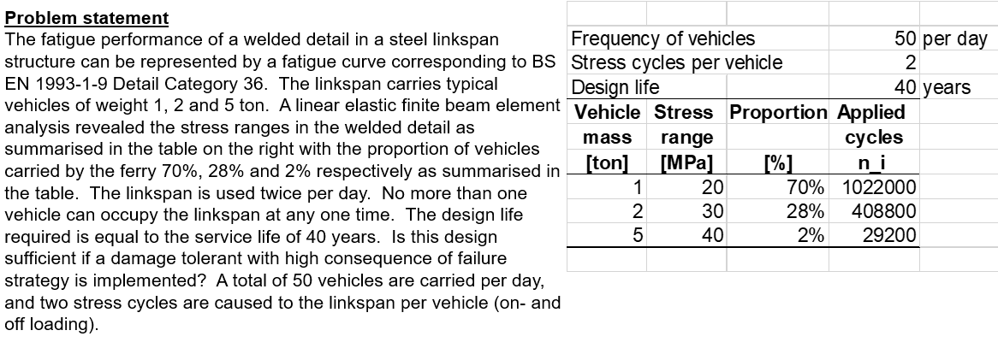

## Solution

### Step 1: Define the fatigue curve

The modified characteristic strength at 2 million cycles is given by:

$$Δσ_{C}=\frac{36}{γ_{MF}}C_{temp}$$

The design requires damage tolerant design with low consequence of failure, that means $γ_{MF}=1.15$.

For temperature, the modification factor at 300 °C is $C_{tem}=0.85$.

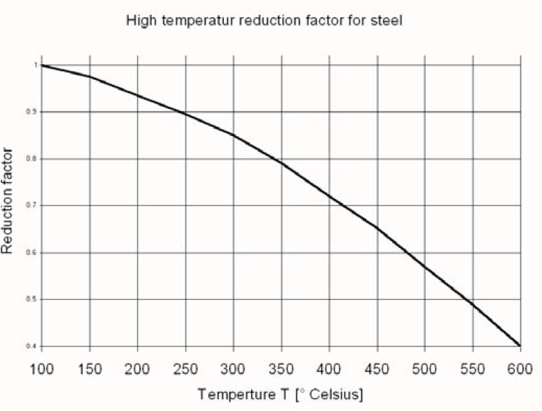

The modified characteristic strength is then:

$$Δσ_{C}=\frac{36}{1.15}0.85 \\ =26.6 MPa$$

The constant amplitude fatigue limit is:

$$Δσ_{D}=Δσ_{C}{\left(\frac{N_{C}}{N_{D}}\right)}^{\frac{1}{m}} \\ ={\left(\frac{2}{5}\right)}^{\frac{1}{3}}Δσ_{C} \\ =0.74Δσ_{C} \\ =19.7 MPa$$

The cut-off limit is:

$$Δσ_{L}=0.41Δσ_{C} \\ =10.8 MPa$$

### Endurance calculation

There are stress ranges exceeding the constant amplitude fatigue limit, therefore, finite life and the Sr-N curve is given by:

$$N_{R}=\left\{\begin{matrix}{\left(\frac{Δσ_{C}}{Δσ_{R}}\right)}^{m_{1}}N_{C} & m_{1}=3 & 1.5f_{y}≥Δσ_{R}≥Δσ_{D} \\ {\left(\frac{Δσ_{D}}{Δσ_{R}}\right)}^{m_{2}}N_{D} & m_{2}=m_{1}+2 & Δσ_{D}≥Δσ_{R}≥Δσ_{L} \\ ∞ & & Δσ_{L}>Δσ_{R}\end{matrix}\right.$$

**For $Δσ=20 MPa$**

$$N_{R1}={\left(\frac{19.7}{20}\right)}^{3}×5E6 \\ =4 778 358 \\ d_{1}=\frac{1 022 000}{4 778 358} \\ =0.21$$

# THIN WALL PRESSURE CYLINDER

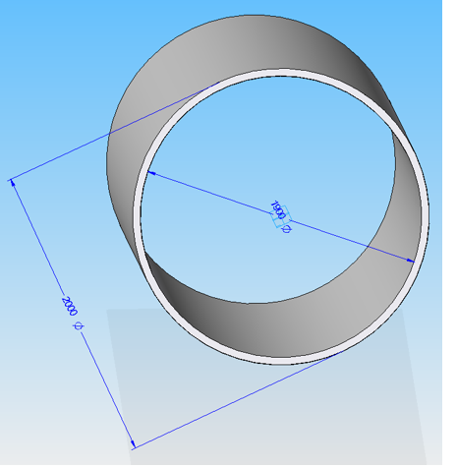

The force that holds the longitudinal loads:

Cross-section area of steel: $A=πDt$  
Area of pressure force: $F_{P}=\frac{π}{4}D^{2}P$  
Stress produced in steel:

$$σA=F_{p}=\frac{π}{4}D^{2}P \\ σ=\frac{\frac{π}{4}D^{2}}{πDt}P \\ =\frac{DP}{4t}$$

# PRESSURE VESSEL DESIGN EXAMPLE

## Problem statement

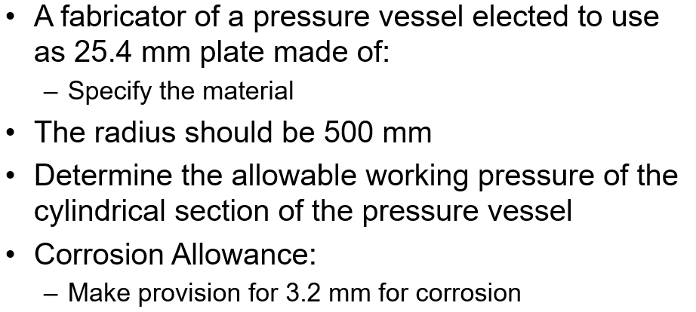

## Solution

### Material selection

Choose plate steel to SA2062. Line 23 below.

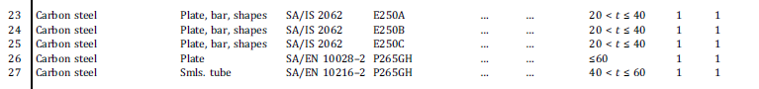

The allowable stress at the operating temperature, assume room temperature, is: .



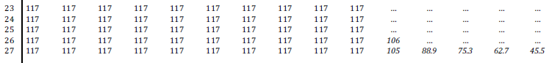

### Joint efficiency

Assume no radiography. Assume welds are all butt welds according to the description below, from which the joint efficiency is $E=0.7$.

### 

### Thickness to use in calculation of design pressure

The thickness of 25.4 mm plate, specified by the client, includes a corrision allowance of 3.2 mm. Therefore, the thicknes to use in the determining the design pressure shall be $25.4-3.2=22.2 mm$

### Maximum allowable operating pressure

We know that the longitudinal (Category A) welds are loaded to the highest stress. Or, in other words, the circumferential stress will govern the maximum allowable pressure.

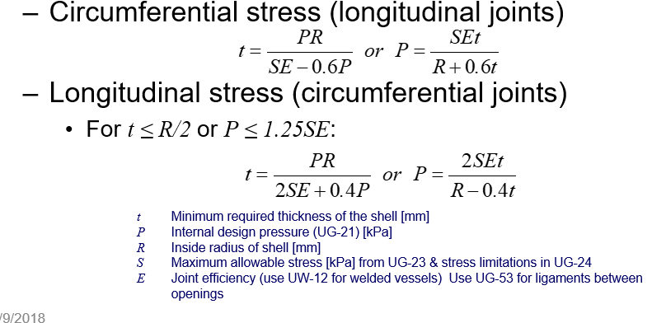

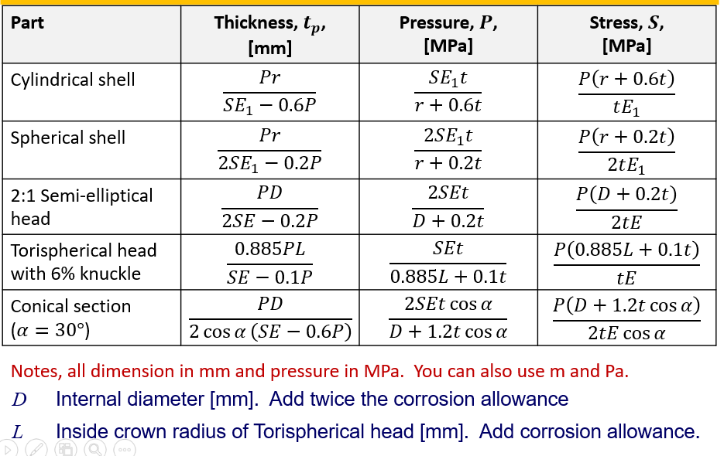

The maximum allowable operating pressure:

$$P=\frac{SE_{1}t}{r+0.6t} \\ =\frac{117×0.7×22.2}{500+0.6×22.2} \\ =3.5 MPa$$

# Acceptable fatigue design question

## Problem Statement

The flange of a welded steel girder is classified as Detail category 125 according to BS EN 1993-1-9. The component is subject to 500 000 cycles for stress range 200 MPa. Adopt a safe life strategy with low consequence of failure. The partial factor for equivalent constant amplitude stress range is $γ_{Ff}=1.0$. Is this design acceptable?

## Solution

Partial factor for fatigue:

From the table below, the partial factor for fatigue strength for safe life and low consequence of failure is $γ_{Mf}=1.15$.

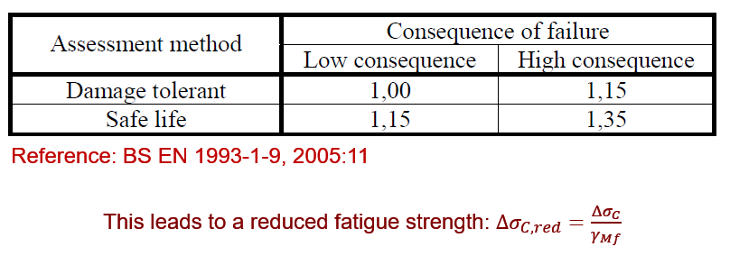

Modification factors

No modification effects requested. So, none applicable.

Fatigue curve

For the stress range given above, the S-N curve equations can be manipulated as below to calculate the endurance at any stress range:

$N_{R}={\left(\frac{\frac{Δσ_{c}}{γ_{Mf}}}{Δσ_{R}} \right)}^{3}N_{c}={\left(\frac{\frac{125}{1.15}}{200}\right)}^{3}2×{10}^{6}=321 000 cycles$. Therefore, the endurance at 200 MPa is 321 000 cycles, which is below the required 500 000 cycles, and, the design do not comply.

ALTERNATIVELY

$$Δσ_{C}=125 MPa$$

Steps:

1. Calculate the stress range at 500 000 cycles, for the partial factor for fatigue modified Sr-N curve.
2. Check if the applied stress range is below the stress range calculated above, if so, the design is acceptable.

Could also:

1. Calculate the endurance at stress range 200 MPa from the partial factor modified Sr-N curve.
2. If the applied number of cycles is < than this endurance, the design is acceptable.

Modification factors

In this case we only need to modify for the safe life strategy with high consequence of failure, for which $γ_{Mf}=1.15$.

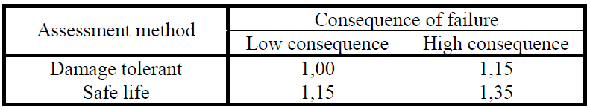

### Check 1

The stress range that the Sr-N curve allows at endurance 500 000 cycles is:

$$Δσ_{R}=\frac{Δσ_{C}}{γ_{Mf}}∙{\left(\frac{N_{C}}{N_{R}}\right)}^{\frac{1}{m_{1}}}$$

Assume the slope of the Sr-N curve is $m_{1}=3$.

Therefore:

$$Δσ_{R}=\frac{125}{1.15}{\left(\frac{2×{10}^{6}}{500000}\right)}^{\frac{1}{3}} \\ =172 MPa$$

This stress range is BELOW the applied stress range, and the design is not acceptable.

### Check 2: Calculate endurance

The endurance $N{}_{R}$ at 200 MPa stress range is 321 000 cycles, which is less than the required 500 000 cycles and the design is not acceptable:

$$N_{R}={\left(\frac{\left(\frac{Δσ_{C}}{γ_{Mf}}\right)}{Δσ_{R}}\right)}^{m_{1}}N_{C} \\ ={\left(\frac{\left(\frac{125}{1.15}\right)}{200}\right)}^{3}×2×{10}^{6} \\ =321 000 cycles$$

# WELD FATIGE EXAMPLE ON 2017-08-15

## Problem statement

The fatigue performance of a welded detail in a steel linkspan structure can be represented by a fatigue curve corresponding to BS EN 1993-1-9 Detail Category 36. The linkspan carries typical vehicles of weight 1, 2 and 5 ton. A linear elastic finite beam element analysis revealed the stress ranges in the welded detail as summarised in the table on the right with the proportion of vehicles carried by the ferry 70%, 28% and 2% respectively as summarised in the table. The linkspan is used twice per day. No more than one vehicle can occupy the linkspan at any one time. The design life required is equal to the service life of 40 years. Is this design sufficient if a damage tolerant with high consequence of failure strategy is implemented? A total of 50 vehicles are carried per day, and two stress cycles are caused to the linkspan per vehicle (on- and off loading).

The exhaust pipe blows are at temperature 350 °C on the link. No post-weld treatment was done, as it was reserved for when failures occur.



## Solution

### Steps

The following steps will confirm the design:

1. Calculate the partial factor for fatigue.
2. Calculate temperature modification factor.
3. Calculate total damage and fatigue life.

### Partial factor for fatigue

For a damager tolerant and high consequence of failure strategy, the partial factor for fatigue is $γ_{Mf}=1.15$.



### Temperature modification factor

The modification factor for temperature for operating at 350°C is $C_{T}=0.79.$



$$C_{T}\left(350°C\right)=0.79$$

### Equation for the S-N curve

The endurance is given as follows:

$$N_{R}=\left[\begin{matrix}{\left(\frac{Δσ_{c}^{'}}{Δσ_{R}}\right)}^{m_{1}}N_{c} & for Δσ_{D}≤Δσ_{R}≤1.5f_{y} \\ {\left(\frac{Δσ_{D}^{}}{Δσ_{R}}\right)}^{m_{2}}N_{D} & for Δσ_{L}≤Δσ_{R}≤Δσ_{D} \\ ∞ & for Δσ_{R}≤Δσ_{L}\end{matrix}\right.$$

The important points on the S-N curve is then:

$$Δσ_{D}=\left(\frac{Δσ_{c}}{γ_{Mf}}×C_{T }\right){\left(\frac{N_{c}}{N_{D}}\right)}^{\frac{1}{3}}=18.2 MPa \\ Δσ_{L}=Δσ_{D}{\left(\frac{N_{D}}{N_{L}}\right)}^{\frac{1}{5}}=10 MPa$$

### Damage calculation

For 20 MPa:

$$N_{R}={\left(\frac{Δσ_{D}}{Δσ_{R}}\right)}^{m_{1}}N_{D}={\left(\frac{18.2}{20}\right)}^{3}5×{10}^{6}=3 781 248$$

$$D_{20}=\frac{1 022 000}{3 781 248}=0.27$$

For 40 MPa:

$$N_{R}=470 981 \\ D_{40}=0.87$$

For 100 MPa:

$$N_{R}=30 249 \\ D_{100}=0.97$$

The total damage is then:

The total damage is then:

$$D_{T}=D_{20}+D_{40}+D_{100} \\ =2.11$$

Therefore the design life of the link for the specified stress spectrum is:

$$DesLife=\frac{40}{2.11} \\ =20 years$$

### The stress spectrum

To calculate the applied cycles over the design life of 40 years, the following formula was used:

$$n_{i}=50×2×365×40×P_{i}$$

## Steps

1. Construct the Sr-N cure. Modify for
   1. Partial fatigue strength factor, $γ_{Mf}$.
   2. Temperature.
   3. Post-weld treatment.
2. Calculate damage.
3. Calculate life.
4. Make recommendations on the use of post—weld treatments if the fatigue life is < design life required.

## Calculate damage

The equation of the Sr-N curve that will be used to calculate endurance, is as follows:



$$N_{R}=\left\{\begin{matrix}{\left(\frac{Δσ_{C,mod}}{Δσ_{R}}\right)}^{m_{1}}N_{C} & for Δσ_{D}≤Δσ_{R}<1.5S_{y} \\ {\left(\frac{Δσ_{D}}{Δσ_{R}}\right)}^{m_{2}}N_{D} & for Δσ_{L}≤Δσ_{R}<Δσ_{D} \\ ∞ & for Δσ_{R}<Δσ_{L}\end{matrix}\right.$$

## What about post-weld treatment

The first to verify, is if the post-weld treatment will be of any benefit for the detail.

When we do peening.

* Special requirements
  + Maximum of nominal compressive stress including proof loading $<0.25f_{y}$
    - Assume we comply
  + Dependent on stress ratio:
    - $R<0$ effective stress range = $Δσ$
    - $0<R≤0.4$ effective stress range = maximum applied stress $σ$
    - $R>0.4$ no benefit

It is assumed that the link is only loaded on one direction, from zero stress to a maximum value equal to the range. In this case $R=0$. Therefore, the effective stress range is as given in the table.

Assume the material is structural steel 350W. For this material, the benefit from peening is as follows:

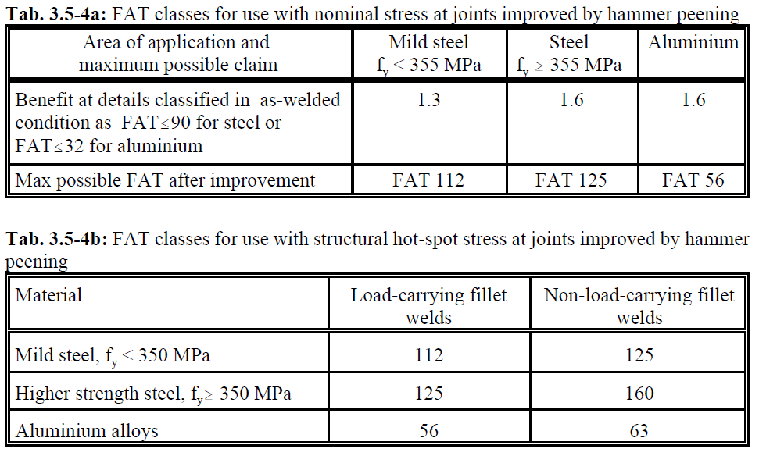



# WELD FATIGE CLASS PROBLEM INCLUDING ALL

An 8 mm double fillet weld was used in a T-joint as shown below. The stress spectrum was calculated over a period of 5 years and is summarized in the table below. The surface is corrosion protected. The component operating temperature is at 250 °C. Because of the small weld that was used in the construction, the weld toes were burred to specification, and peened to specification afterwards. The stress range has in all cases a stress ratio of R=-0.2. The component was heat treated before post-weld treatment. The design strategy is damage tolerant with low consequence of failure. What is the fatigue life of the component?

Table 6: Stress spectrum over a period of 5 years



$$Δσ$$

50

50

Width: $w=200$

## Solution

The following procedure will be used:

1. Find the partial factor for fatigue.
2. Calculate modification factors:
   1. Temperature.
   2. Size.
   3. Post-weld treatment.
   4. Heat-treatment effects.
3. Determine detail categories.
4. Determine the equation for the S-N curve for crack initiation at the:
   1. Weld toe.
   2. Weld root.
5. Calculate damage.
6. Calculate life.

### Partial factor for fatigue

For a damage tolerant and low consequence of failure, the partial factor for fatigue is $γ_{Mf}=1.0.$



### Modification factors/effects

#### Temperature

The modification factor for operation at 250 °C is $C_{T}=0.9.$



### Detail category: crack initiation at the weld toe

The detail category for crack initiation at the weld toe is $Δσ_{C_{toe}}=71$. This detail will benefit from heat treatment, weld toe treatment, and, peening.

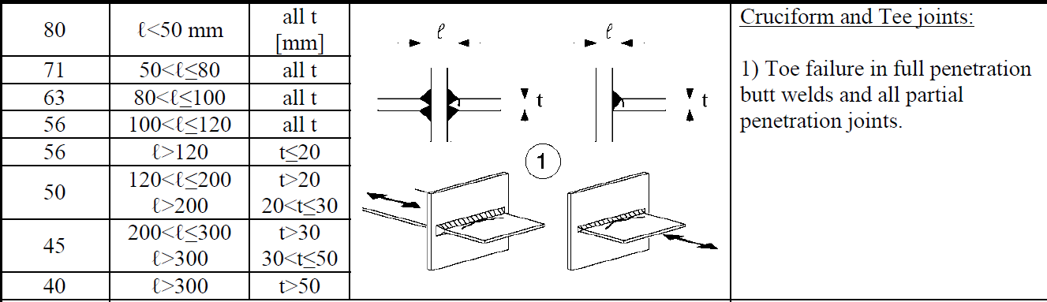

### Detail category: crack initiation in the weld root

In this case, the detail category is marked with an *, and can be moved one category up. In this case conservativeness is not so important and the detail category was raised by one level to $Δσ_{C_{throat}}=40$ (see S-N curves below). This detail will NOT benefit from weld toe treatment or peening. But, it will benefit from heat treatment.

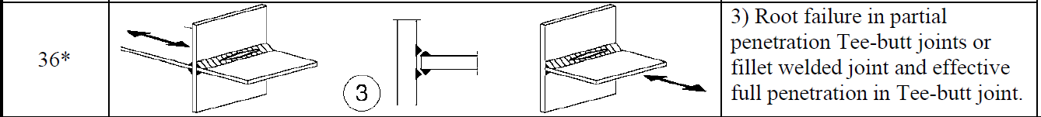

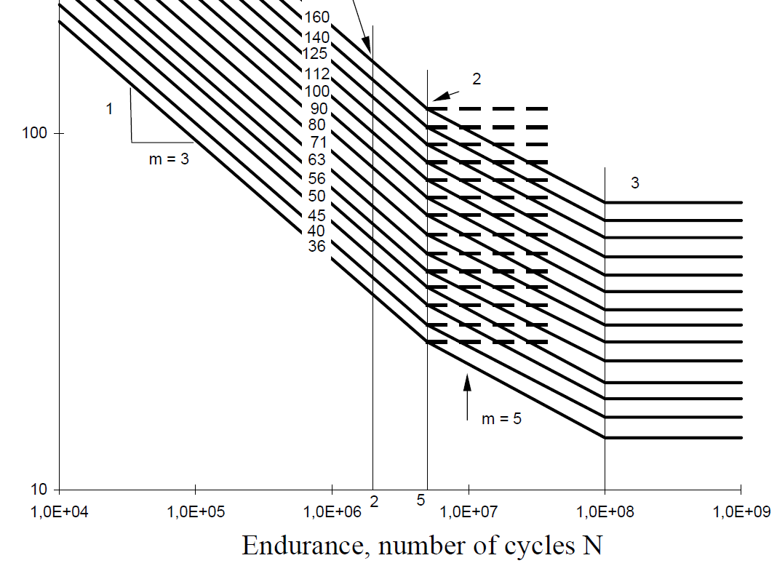

### Heat treatment

In this case heat treatment allows the use of 60% of the compressive part in the stress signal for range calculation. The stress spectrum only provides the stress range and stress ratio. To calculate the compressive stress and effective stress range for every given stress range, the following equation was used:

$$R=\frac{σ_{min}}{σ_{max}} \\ R_{HT}=\frac{0.6σ_{min}}{σ_{max}}=0.6R \\ σ_{min}=Rσ_{max} \\ Δσ=σ_{max}-σ_{min} \\ =σ_{max}(1-R)$$

Steps to follow:

1. Calculate $σ_{max}=\frac{Δσ}{1-R}$
2. Calculate new stress range from: $Δσ_{HT}=σ_{max}\left(1-R_{HT}\right)=Δσ×\frac{1-R_{HT}}{1-R}$

### Grinding and peening for improvement at the weld toe

The problem statement mentioned grinding, then peening afterwards. In this case, we can have the benefit of both provided that we do not exceed the limits as specified.

#### Grinding

For toe grinding the benefit and finale characteristic strength is:

$$Δσ_{C_{g}}=\min\left\{\begin{matrix}1.3Δσ_{C} & \\ 112 & \end{matrix}\right.$$

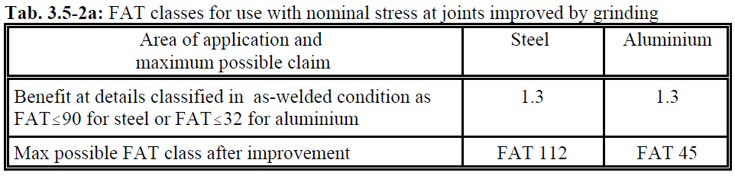

#### Peening

The benefit from peening after grinding is:



$$Δσ_{C_{p}}=\min\left\{\begin{matrix}1.3Δσ_{C_{g}} & \\ 112 & \end{matrix}\right.$$

### Stress in the weld throat

The stress in the weld throat from the nominal stress as given will be calculated as follows:

$$Δσ_{w}a_{w}w=Δσtw \\ Δσ_{w}=\frac{Δσt}{a_{w}}$$

### Damage calculation and fatigue life assessment

The equation for the S-N curve will calculated endurance for any stress range as follows:

$$N_{R}=\left\{\begin{matrix}{\left(\frac{Δσ_{D}}{Δσ_{R}}\right)}^{m_{1}}N_{D} & for Δσ_{D}≤Δσ_{R}≤1.5f_{y}, m_{1}=3 \\ {\left(\frac{Δσ_{D}}{Δσ_{R}}\right)}^{m_{2}}N_{D} & for Δσ_{L}≤Δσ_{R}<Δσ_{D}, m_{2}=5 \\ ∞ & for Δσ_{R}<Δσ_{L}\end{matrix}\right.$$

### Fatigue life for crack initiation at the weld toe

The fatigue life for 95% probability of survival for crack initiation at the weld toe is 16.9 years.



### Fatigue life for crack initiation at the weld throat

The fatigue life for 5% probability of crack initiation in the weld throat is 2.16 days! Please redesign this thing.



# PRESSURE VESSEL EXAMPLE 1

## Problem statement

* A fabricator of a pressure vessel elected to use as 25.4 mm plate made of:
  + Specify the material
* The radius should be 500 mm
* Determine the allowable working pressure of the cylindrical section of the pressure vessel
* Corrosion Allowance:
  + Make provision for 3.2 mm for corrosion

Answer in class in the class notes document

## Solution

Methodology:

1. Select a material that can handle the operating temperature and environment.
2. Assume no non-destructive testing. Find joint efficiency for category A welds with no NDT.
3. Calculate a thickness of t=25.4 – 3.2.
4. Calculate pressures for this t.

### Select material

No temperature was specified and it is assumed that the vessel will operate under room temperature. The selection of the material was done as follows:

1. Selected materials that can offer a wide thickness range. I can always iterate this process if the plate selected now is not the best option.
2. Confirmed that the material can be used at the operating temperature.

This resulted in the selection of the following material:

SA-537 Plate, S = 20 ksi at room temperature

The maximum allowable stress on this material at room temperature is 140 MPa.

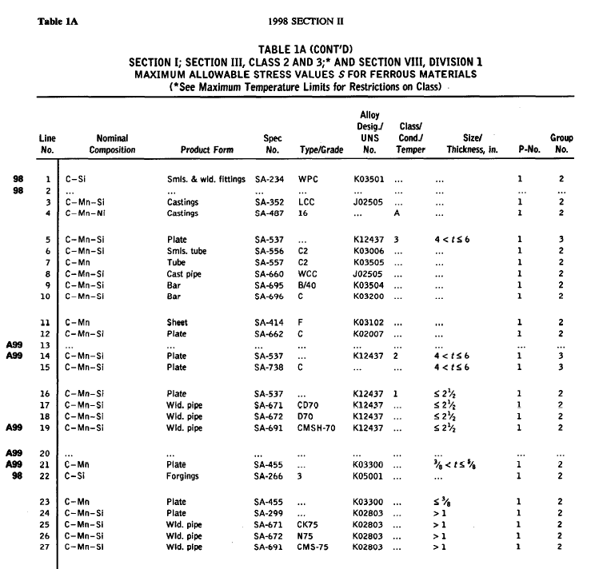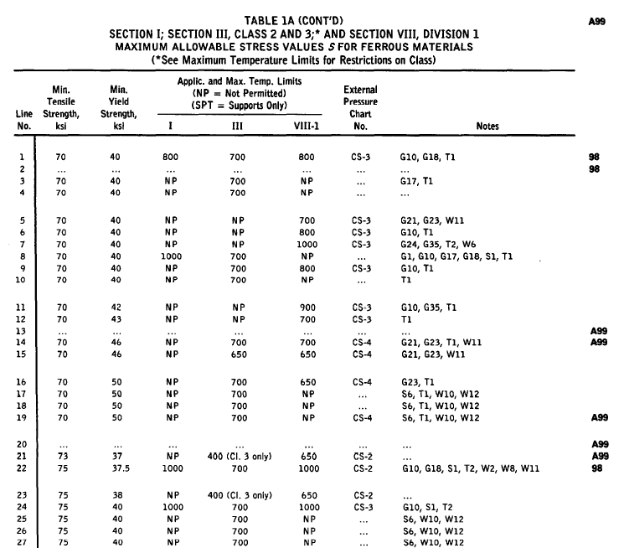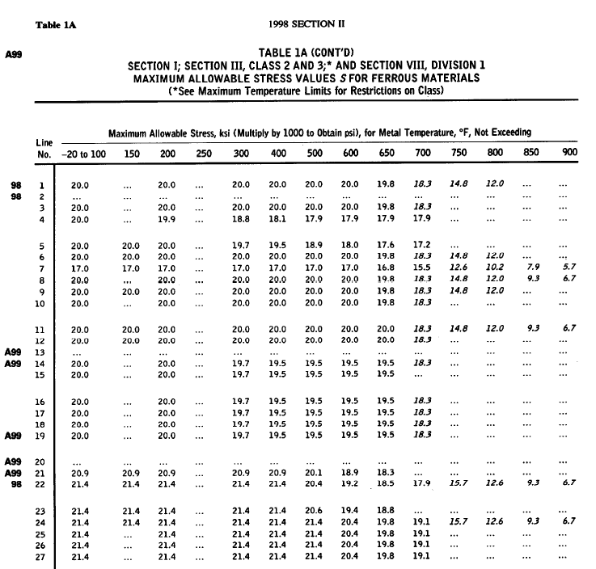

### Joint efficiency

The circumferential stress is the highest. Therefore, joint efficiencies for Joint A is required. No information on the welds were given. An instruction will be given for the WPS to specify a welding from one side without a backing strip. For this weld with no post-weld NDT, the joint efficiency is $E=0.6$.



## Applicable equations

From the table below, the pressure for the cylindrical shell is given by (the thickness $t=t_{plate}-t_{corrosion}$):

$$P=\frac{SEt}{r+0.6t} \\ =\frac{140∙0.6∙0.0222}{0.5+0.6∙0.0222} \\ =3.6 MPa$$

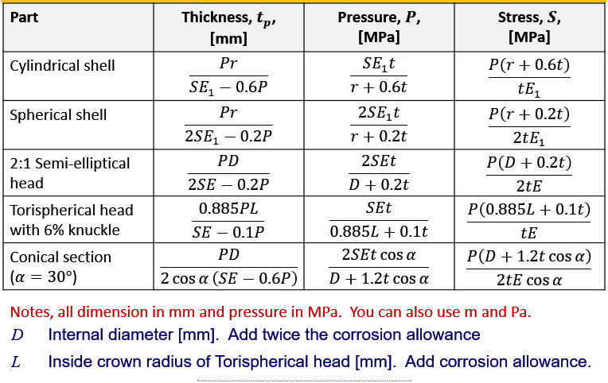

# PRESSURE VESSEL AND CHECK FOR BUCKLING

## Problem statement

* A horizontal vessel with inside diameter 1,500 mm is to be fabricated from SA-516 Grade 70 material. The design pressure at the top of the vessel is 3,378 kPa (3.4 MPa) at 216 °C. This measurement point was at a height of 1.5 m above the centerline of the cylinder.
  + All longitudinal joints shall be Type 1 and spot radiographed in accordance with UW-52
  + Circumferential joints are Type 1 with no radiography
* Vessel operates full of liquid with density 998 kg/m3. Distance from the centerline to the uppermost part of vessel is 1.5 m.
* Determine the required thickness at Point A
  + Neglect the weight of the vessel in the calculation
* UG-22 states that the static head of the liquid must be included in the pressure P

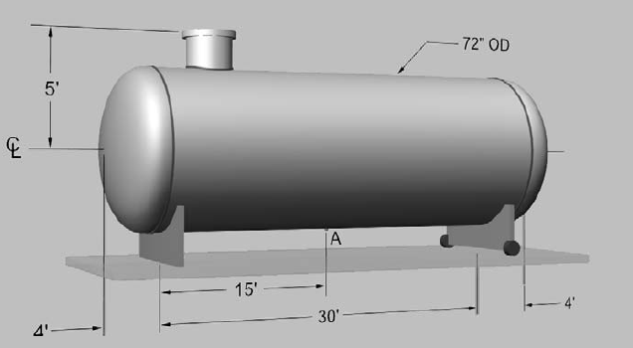

## Solution

1. Calculate the design pressure.
2. Find the maximum allowable design stress.
3. Circumferential stress
   1. Find joint efficiency.
   2. Calculate $t$
4. Longitudinal stress at the bottom
   1. Find joint efficiency
   2. Calculate bending stress
   3. Calculate $t$
   4. Calculate stress at the top of the vessel.
      1. If < 0, check for buckling.
5. Add thickness for corrosion

### Design pressure

The pressure at the top of the vessel was given 3 378 kPa. However, hydrostatic pressure need to be included and from this the design pressure is:

$$P=3 378×{10}^{3}+ρgh \\ =3 378×{10}^{3}+998×9.81×2.25 \\ =3.4 MPa$$

### Maximum allowable design stress

The temperature is 443 °F. For this, the maximum allowable stress is 20 ksi, 140 MPa.

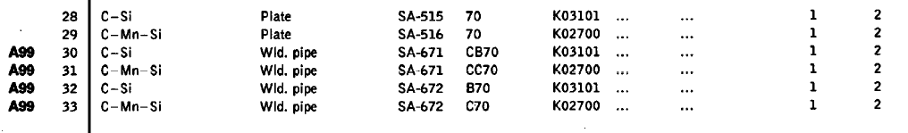

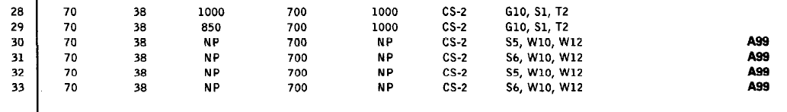

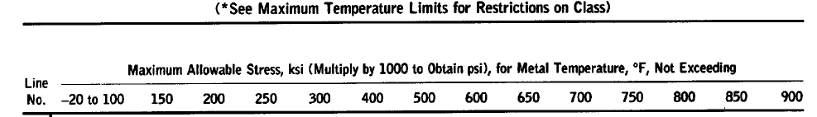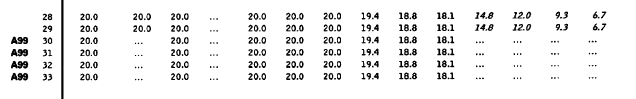

### Circumferential stress

#### Joint efficiency and thickness

The joint efficiency for the longitudinal welds is $E=0$.85. The thickness required is:

$$t=\frac{Pr}{SE-0.6P} \\ =\frac{3400×0.75}{140000×0.85-0.6×3400} \\ =21.8 mm$$

Confirm that this thickness is available for the material.





### Longitudinal stress at the top

The longitudinal stress due to pressure and bending is given by the following equation:

$$σ_{top}=\frac{My}{I}+\frac{P\left(R+0.2t\right)}{t} \\ =-\frac{WL^{2}R_{o}}{8∙\frac{π}{4}\left(R_{o}^{4}-R_{i}^{4}\right)}+\frac{P\left(R_{i}+0.2t\right)}{t}$$

$=-3.4 MPa$ Ag nee, this is tto small to demonstrate buckling. Say it is: $$=-80 MPa$$

The maximum bending moment is at the centre of the pressure vessel:

$$M=\frac{WL^{2}}{8} \\ W=9.81×998\left(πr^{2}\right) \\ L=\frac{30}{3.3}=9 m$$

$$P=\frac{2SEt}{R+0.2t} \\ SE=\frac{P\left(R+0.2t\right)}{t}$$

There is compressive stress. Confirm buckling.

### Confirm buckling

Step 1: Calculate A

$$A=\frac{0.125}{\frac{R_{o}}{t}} \\ =0.0034$$

Step 2: Factor B from graph

From the graph below, the factor is $B=12.400 ksi \sim 100 MPa$. Therefore, the thickness is adequate to prevent buckling because $B=100 MPa$ is more than the compressive stress of 80 MPa.

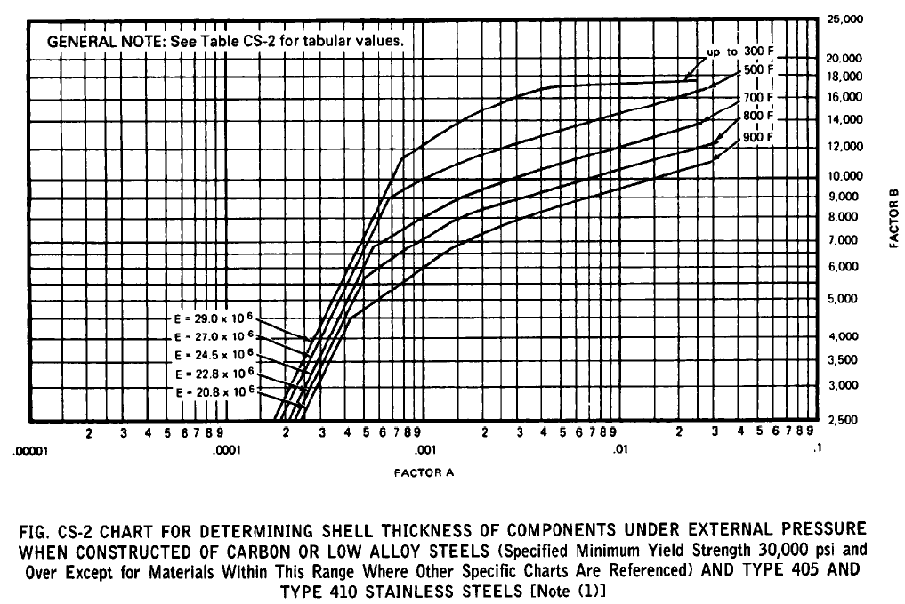

### Check longitudinal stress at bottom

$$σ_{b}=\frac{WL^{2}R_{o}}{8∙\frac{π}{4}\left(R_{o}^{4}-R_{i}^{4}\right)} \\ =3.6 MPa$$

This is small contribution and will be neglected.

# PLANE STRESS AND STRAIN

The constitutive model for isotropic materials:

$$ε_{x}=\frac{σ_{x}}{E}-\frac{ν}{E}\left(σ_{z}+σ_{y}\right) \\ ε_{y}=\frac{σ_{y}}{E}-\frac{ν}{E}\left(σ_{z}+σ_{x}\right) \\ ε_{z}=\frac{σ_{z}}{E}-\frac{ν}{E}\left(σ_{x}+σ_{y}\right)$$

Say we have stress state: $σ_{x}=1, σ_{y}=0 and σ_{z}=0$

Under plane strain conditions, the strains $ε_{y}=ε-z=0$. Then stresses $σ_{y} and σ_{z}$ will be generated because:

$$ε_{x}=\frac{σ_{x}}{E}-\frac{ν}{E}\left(σ_{z}+σ_{y}\right) \\ 0=\frac{σ_{y}}{E}-\frac{ν}{E}\left(σ_{z}+σ_{x}\right) \\ 0=\frac{σ_{z}}{E}-\frac{ν}{E}\left(σ_{x}+σ_{y}\right)$$

# FRACTURE MECHANICS

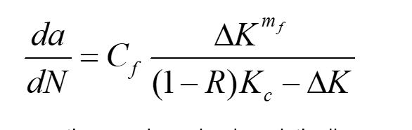



# FRACTURE MECHANICS CLASS PROBLEM

## Problem statement

You have a rectangular cross section steel part with yield strength 500 MPa and Charpy test energy 35 J that has a double edge crack measured 2 mm on each side. The part is subject to a axial stress amplitude 100 MPa, mean 0 MPa, for 50 cycles per hour. The width of the part is 250 mm and thickness is 30 mm. The part is used for 8 hours per day. For how long can the part be used before failure? What can be done to increase the fatigue life.

## Solution

Steps:

1. Determine the plane strain fracture toughness of the material.
2. Calculate the crack size where failure occur.
   1. Fracture
   2. Plastic collapse
3. Get a model for the geometric stress concentration factor.
4. Set up the Paris rule for crack propagation.
5. Solve

### Plane strain fracture toughness

A lower bound for the plane strain fracture toughness will be used, given by:

$$K_{Ic}=21.6{\left(C_{v}\right)}^{0.17} MPa\sqrt{m}$$

### Fracture

Fracture occurs when the crack size reaches a value so that the stress intensity factor equals the plane strain fracture toughness at the maximum tensile stress:

$$K_{I}=β\left(a\right)σ\sqrt{πa} \\ a_{fr}={\frac{1}{π}\left(\frac{K_{IC}}{β\left(a_{fr}\right)σ_{max}}\right)}^{2}$$

The geometric stress concentration factor is given by the following figure:

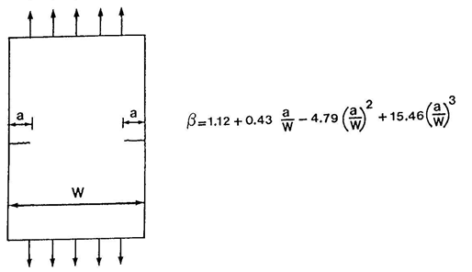

### Plastic collapse

Plastic collapse occurs when the crack size reaches a value so that the stress in the remaining section becomes equal to the yield strength:

$$σ_{rem}=\frac{F_{nom}}{B\left(W-2a\right)} \\ =\frac{σ_{nom}WB}{B\left(W-2a\right)} \\ S_{y}\left(W-2a_{col}\right)=\frac{σ_{nom}WB}{B} \\ W-2a_{col}=\frac{σ_{nom}WB}{BS_{y}} \\ 2a_{col}=W-\frac{σ_{nom}WB}{BS_{y}} \\ a_{col}=\frac{1}{2}\left(W-\frac{σ_{nom}WB}{BS_{y}}\right)$$

### Crack propagation

The crack propagation will be modelled as follows:

$$\frac{da}{dN}=CΔ{K^{+}}^{m}$$ where

$$C=1×{10}^{-8} \\ m=3$$

## Calculation sheet

For this load application the stress ration is -1. Therefore the threshold stress intensity level is 5.4 MPam0.5. The applied stress intensity range is 8.9 MPam0.5, which is higher than threshold value, and, crack propagation will occur. From the table below, the crack will propagate to 36 mm in 450 cycles where the fracture toughness is reached. The component fails in fracture. For fracture collapse, a material with plane strain facture toughness of 70 MPam0.5 or more is required to allow the crack to grow to 100 mm in length.

Life can be extended by:

1. Repairing the crack.
2. Drill-stop the crack.
3. Retard the crack by tensile overloading.

