FORMULA SHEET: Fatigue, Fracture Mechanics

Structural Mechanics
$$σ_{i}=\frac{M_{x}y_{i}}{I_{xx}}-\frac{M_{y}x_{i}}{I_{yy}}+\frac{F}{A} \\ ε_{x}=\frac{σ_{x}}{E}-\frac{ν}{E}\left(σ_{y}+σ_{z}\right)+αΔT$$

Fatigue: Machined Components
$$σ_{ar}^{m}N=C \\ σ_{ar,1}^{m}N_{1}=σ_{ar,2}^{m}N_{2} \\ m=\frac{\log\left(\frac{N_{2}}{N_{1}}\right)}{\log\left(\frac{σ_{ar,1}}{σ_{ar,2}}\right)} \\ N_{R}=\left\{\begin{matrix}{\left(\frac{σ_{ar,1}}{σ_{ar}}\right)}^{m}N_{1} & {0.9σ_{u}≥σ}_{ar}≥σ_{er} \\ ∞ & σ_{ar}<σ_{er}\end{matrix}\right.$$
OR
$$σ_{ar}N^{b}=C \\ σ_{ar,1}N_{1}^{b}=σ_{ar,2}N_{2}^{b} \\ b=\frac{\log\left(\frac{σ_{ar,1}}{σ_{ar,2}}\right)}{\log\left(\frac{N_{2}}{N_{1}}\right)} \\ N_{R}=\left\{\begin{matrix}{\left(\frac{σ_{ar,1}}{σ_{ar}}\right)}^{\frac{1}{b}}N_{1} & {0.9f_{ut}≥σ}_{ar}≥S_{e} \\ ∞ & σ_{ar}<S_{e}\end{matrix}\right.$$
Endurance limit estimates (see Dowling Table 10.1)
$$σ_{erb}=\left\{\begin{matrix}0.25BHN ksi & for BHN≤400 \\ 100 ksi & for BHN>400\end{matrix}\right.$$
Steel
$$σ_{erb}=\left\{\begin{matrix}0.5σ_{u} & for σ_{u}≤200 ksi (1 400 MPa) \\ 100 ksi (700 MPa) & for σ_{u}>200 ksi (1 400 MPa)\end{matrix}\right.$$
Cast Iron + Cast Steels:
$$σ_{erb}=\left\{\begin{matrix}0.45σ_{u} & for σ_{u}≤600 MPa \\ 275 MPa & for σ_{u}>600 MPa\end{matrix}\right.$$

Stress concentrations
- $K_{f}$:
$$σ_{sc}=K_{t}S \\ K_{t}=\frac{σ_{sc}}{S} \\ K_{f}=\frac{σ_{erb}^{\left(un-notched\right)}}{σ_{erb}^{\left(nothced\right)}} \\ K_{f}=1+\frac{K_{t}-1}{\left(1+\frac{α}{r}\right)}$$
- Approximations for $α$:
$$α={\left[\frac{300}{σ_{u}\left[ksi\right]}\right]}^{1.8}×{10}^{-3} in. \\ ={\left[\frac{300×6.89}{σ_{u}\left[MPa\right]}\right]}^{1.8}×{10}^{-3}×25.4 mm$$
Peterson for steels (Dowling, 2013, p. 498):
$$\log{α}=2.654×{10}^{-7}σ_{u}^{2}-1.309×{10}^{-3}σ_{u}+0.01103$$
$$α \left[in mm\right]={10}^{\log{α}} \left(345≤σ_{u}≤2 070 MPa\right) \\ ={10}^{2.654×{10}^{-7}σ_{u}^{2}-1.309×{10}^{-3}σ_{u}+0.01103}$$
Typical values are:
$$α=\left\{\begin{matrix}0.51 mm & aluminium alloys \\ 0.25 mm & annealed or normalized low-carbon steels \\ 0.064 mm & quenched and tempered steels\end{matrix}\right.$$
- $K_{f}^{'}$:
$$\frac{K_{f}^{'}-1}{K_{f}-1}=f\left(σ_{u}\right)=q$$
$$σ_{arb,1000}^{'}=\frac{σ_{arb,1000}}{K_{f}^{'}} \\ σ_{erb}^{'}=\frac{σ_{erb}}{K_{f}}$$
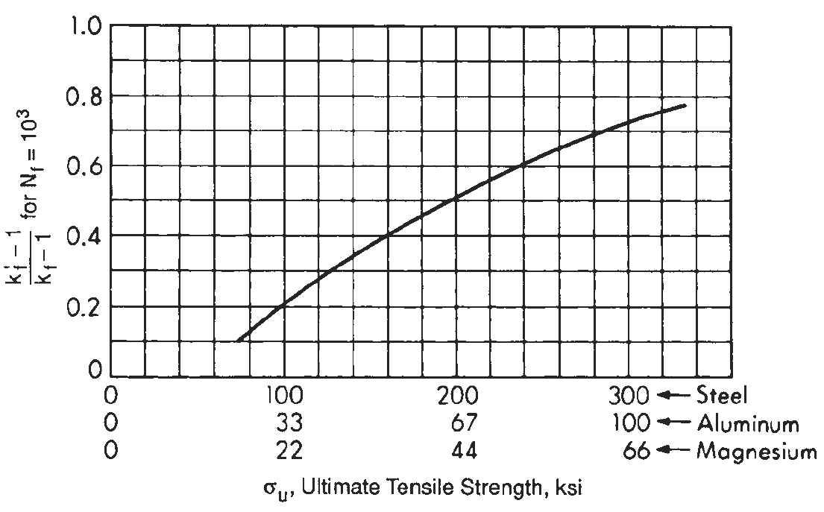

Mean stress correction
Approach | Equations
Modified Goodman | $$σ_{ar}=\frac{σ_{a}}{1-\frac{σ_{m}}{σ_{u}}}$$
Gerber | $$σ_{ar}=\frac{σ_{a}}{1-{\left(\frac{σ_{m}}{σ_{u}}\right)}^{2}}, for σ_{m}≥0$$
Morrow | $$σ_{ar}=\frac{σ_{a}}{1-\frac{σ_{m}}{σ_{f}^{'}}}$$
SWT | $$σ_{ar}=\sqrt{σ_{max}σ_{a}} \\ =\sqrt{\left(σ_{m}+σ_{a}\right)σ_{a}} \\ =σ_{max}\sqrt{\frac{1-R}{2}}$$
Walker | $$σ_{ar}=σ_{max}^{1-γ}σ_{a}^{γ} \left(σ_{max}>0\right) \\ =σ_{max}{\left(\frac{1-R}{2}\right)}^{γ} \left(σ_{max}>0\right)$$  $$γ=\begin{matrix}-0.000200σ_{u}+0.8818 & (σ_{u} in MPa)\end{matrix}$$

Juvinall & Budynas (Dowling, 2013, p. Table 10.1)
Juvinall
$$m^{'}=\left\{\begin{matrix}0.90 & k_{f}^{'}=k_{f} & bending, torsion (τ_{u} in σ_{u}) \\ 0.75 & k_{f}^{'}=k_{f} & axial\end{matrix}\right.$$
Budynas:
$$m^{'}=\left\{\begin{matrix}0.90 & σ_{u}<483 MPa \\ 0.2724x^{2}-1.918x+4.012 & x=\log_{10}{σ_{u}}, σ_{u}≥483 MPa \\ k_{f}^{'}=k_{f} & \end{matrix}\right.$$

Modifying factors
$$σ_{er}=σ_{erb}^{'}C_{size}C_{load}C_{surf}C_{T}C_{rel} \\ σ_{erb}^{'}=\frac{{m_{e}σ}_{erb}}{K_{f}} \\ σ_{ar,{10}^{3}}=σ_{arb,{10}^{3}}^{'}C_{load}C_{T}C_{rel} \\ σ_{arb,{10}^{3}}^{'}=\frac{m^{'}σ_{u}}{K_{f}^{'}}$$
Size:
$$C_{size}=\left\{\begin{aligned}1.0, if d≤8 mm \\ 1.189d^{-0.097},if 8 mm<d≤250 mm\end{aligned}\right.$$
Load:
$$σ_{er,axial}=0.70σ_{erb}$$$C_{load}=0.7$ for axial loading if the fatigue S-N curve was obtained from completely reversed bending loading.
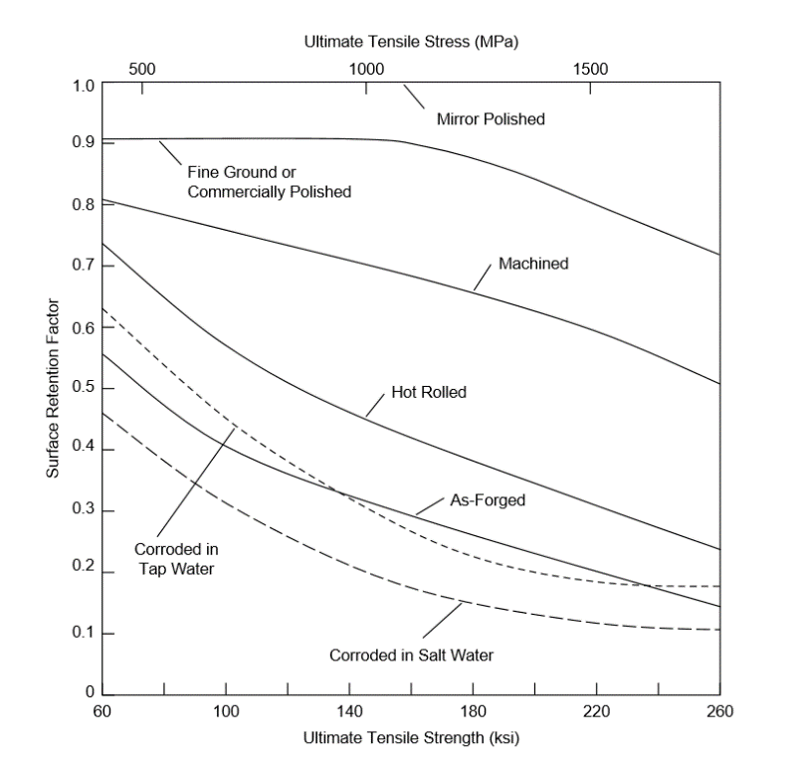
Temperature:
$$C_{T}=\left\{\begin{matrix}1.0 for T≤450 ℃ \\ 1-{5.8}^{-3}\left(T-450\right), for 450<T≤550 ℃\end{matrix}\right.$$
Reliability:
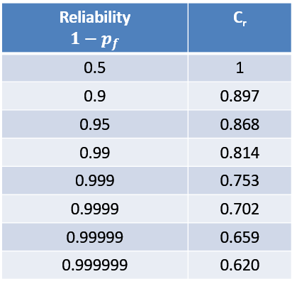

Fatigue: Large scale manufactured components
$$Δσ_{C,mod}=\frac{Δσ_{C}}{γ_{Mf}}C_{t}C_{T}C_{PWT} \\ Δσ_{D}=Δσ_{C,mod}{\left(\frac{N_{C}}{N_{D}}\right)}^{\frac{1}{m_{1}}}$$
$$N_{R}=\left\{\begin{matrix}{\left(\frac{Δσ_{D}}{Δσ_{R}}\right)}^{m_{1}}N_{D} & m_{1}=3 & 1.5f_{y}>Δσ_{R}≥Δσ_{D} \\ {\left(\frac{Δσ_{D}}{Δσ_{R}}\right)}^{m_{2}}N_{D} & m_{2}=5 & Δσ_{D}>Δσ_{R}≥Δσ_{L} \\ ∞ & & Δσ_{R}<Δσ_{L}\end{matrix}\right. \\ N_{C}=2×{10}^{6} cycles \\ N_{D}=5×{10}^{6} cycles \\ N_{L}=100×{10}^{6} cycles$$
$$Δσ_{C,mod}=\frac{Δσ_{C}}{γ_{Mf}}{C_{t}C}_{T}C_{PWT}$$
Partial factor for fatigue:
Assessment | Consequence of failure
 | Low | High
Damage tolerant | 1.0 | 1.15
Safe life | 1.15 | 1.35

Temperature:
$$Δ_{C,HT}=Δσ_{C}\frac{E_{HT}}{E_{20°C}}$$
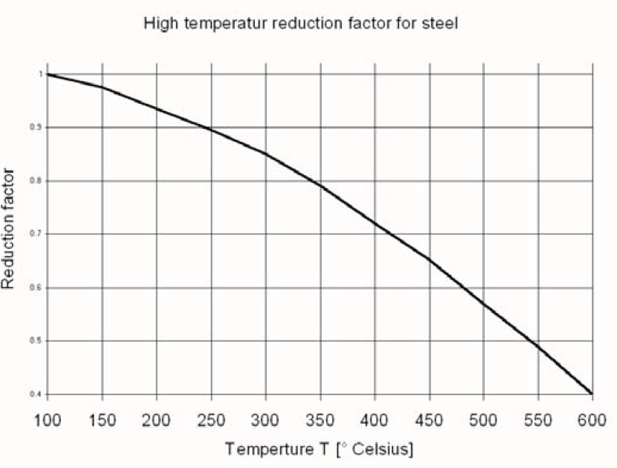
0.6
0.4
0.8
Grinding & TIG dressing:
Effective stress range: $Δσ=Δσ$
Steel:
$$Δσ_{C}=min\left\{\begin{matrix}1.3×Δσ_{C} \\ 112\end{matrix}\right.$$
Aluminium:
$$Δσ_{C}=min\left\{\begin{matrix}1.3×Δσ_{C} \\ 45\end{matrix}\right.$$

Peening:
Effective stress range:
$$Δσ=\left\{\begin{matrix}Δσ & R>0 \\ σ_{max} & 0<R≤0.4 \\ No benefit & R>0.4\end{matrix}\right.$$
$$Δσ_{c,mod}=\left\{\begin{matrix}Steel & f_{y}<355 & \min{(1.3Δσ_{c}, 112)} \\ Steel & f_{y}≥355 & \min{(1.6Δσ_{c}, 125)} \\ Al & & \min{(1.6Δσ_{c}, 56)}\end{matrix}\right.$$

Fracture Mechanics
Universal equation: $K=βσ\sqrt{πa}$
Plastic collapse: $F_{pc}=\frac{f_{y}}{A_{nett}}$
Fracture:
$$K=K_{Ic} \\ K_{Ic}=βσ\sqrt{πa_{f}} \\ a_{f}=\frac{1}{π}{\left(\frac{K_{Ic}}{βσ}\right)}^{2} \\ σ_{f}=\frac{K_{Ic}}{β\sqrt{πa_{fr}}}$$
$$a_{cri}=\min\left\{\begin{matrix}a_{pc} & for plastic collapse \\ a_{f} & for fracture\end{matrix}\right.$$
Stress concentration factors:
Centre cracked plate: $β=1+0.256\left(\frac{a}{W}\right)-1.152{\left(\frac{a}{W}\right)}^{2}+12.2{\left(\frac{a}{W}\right)}^{3}$
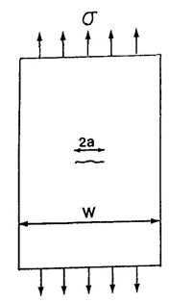

Single edge crack:
$$β=1.12-0.23\left(\frac{a}{W}\right)+10.56{\left(\frac{a}{W}\right)}^{2}-21.74{\left(\frac{a}{W}\right)}^{3}+30.42{\left(\frac{a}{W}\right)}^{4}$$
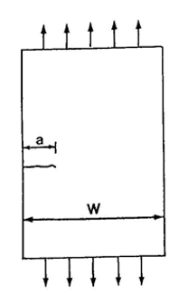
Double edge crack:
$$β=1.12+0.43\left(\frac{a}{W}\right)-4.79{\left(\frac{a}{W}\right)}^{2}+15.46{\left(\frac{a}{W}\right)}^{3}$$
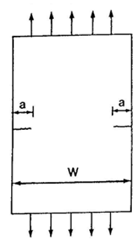
LEFM
$$B, W-a, a≥2.5{\left(\frac{K_{Ic}}{f_{yt}}\right)}^{2} \\ W≥5.0{\left(\frac{K_{Ic}}{f_{yt}}\right)}^{2}$$
Fracture toughness estimation: $K_{IC}=11.4\sqrt{C_{v}}$
Lower limit: $K_{IC}=21.6{\left(C_{v}\right)}^{0.17}$
Note, $C_{v}$ in Joule, $K_{IC}$ in $MPa.\sqrt{m}$
Crack growth
$$\frac{da}{dN}=C_{p}{\left(ΔK^{+}\right)}^{m_{p}}$$
$$\int_{0}^{N}{dN}=\int_{a_{i}}^{a_{e}}{\frac{1}{C_{p}{\left(βΔσ\sqrt{πa}\right)}^{m_{p}}}da}$$

Pressure equipment
$$P_{des}=P+ρgh$$
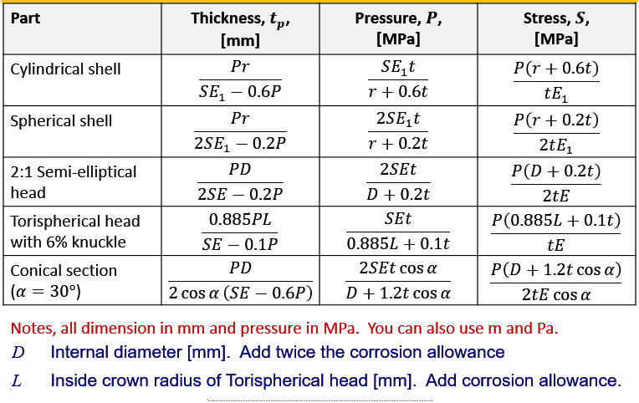

Interpolation on a logarithmic scale using your ruler
$$\frac{\log_{10}\left.N\right.-\log_{10}{x_{1}}}{\log_{10}{x_{2}-\log_{10}{x_{1}}}}=\frac{a}{b} \\ \log_{10}{N}=\frac{a}{b}\left(\log_{10}{x_{2}-\log_{10}{x_{1}}}\right)+\log_{10}{x_{1}} \\ N={10}^{\left(\frac{a}{b}\left(\log_{10}{x_{2}-\log_{10}{x_{1}}}\right)+\log_{10}{x_{1}}\right)}$$
$$x_{1}$$
$$x_{1}$$
$$N$$
$$a$$
$$b$$

CONVERSIONS
1 ksi = 6.89 MPa

Detail catgories
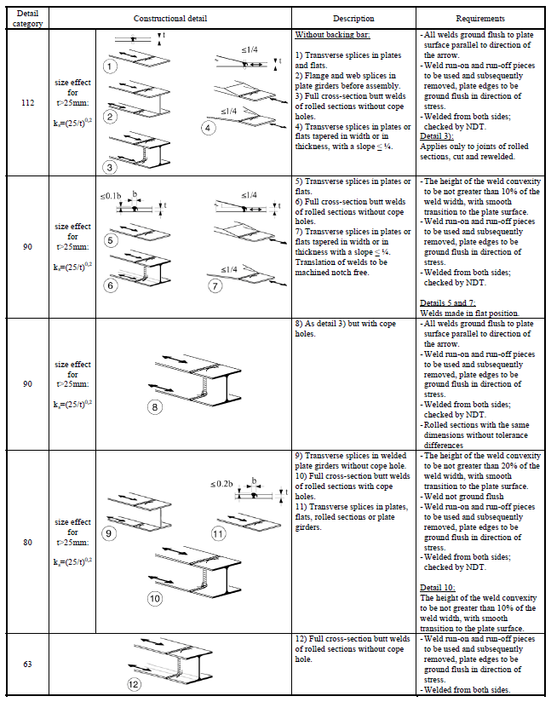

Joint efficiencies
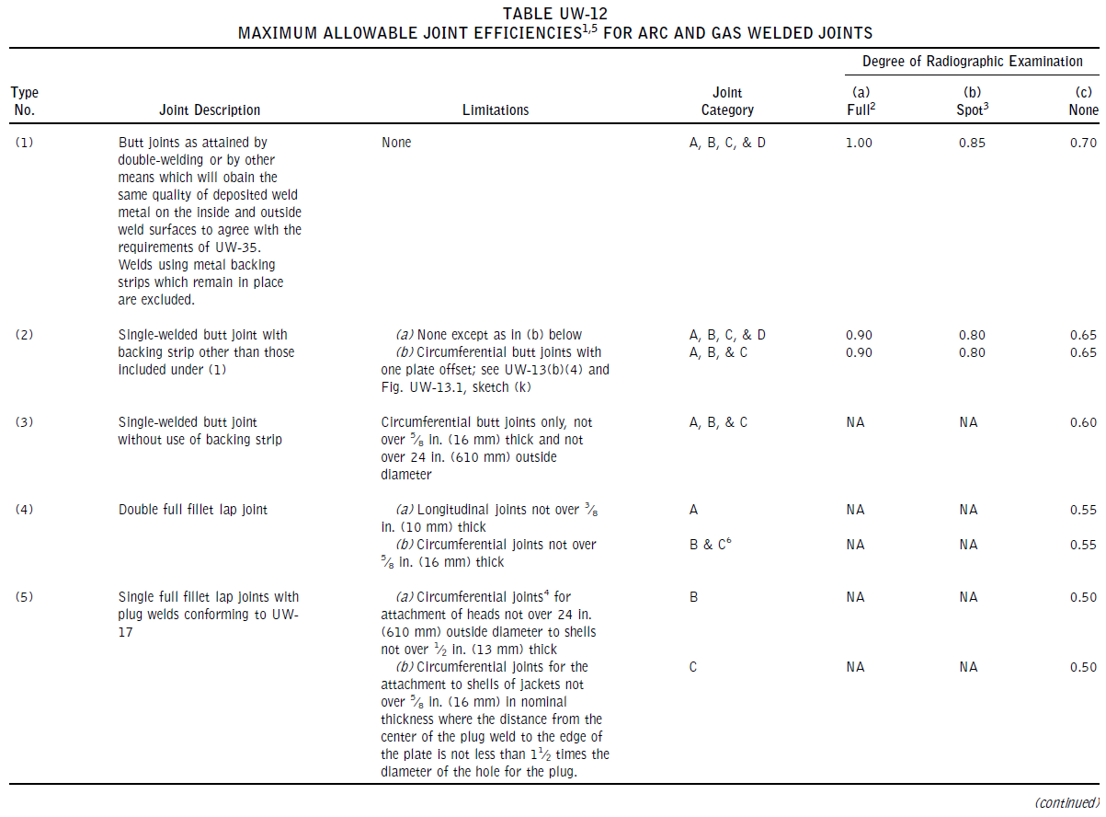

Vessels – Dangerous gas
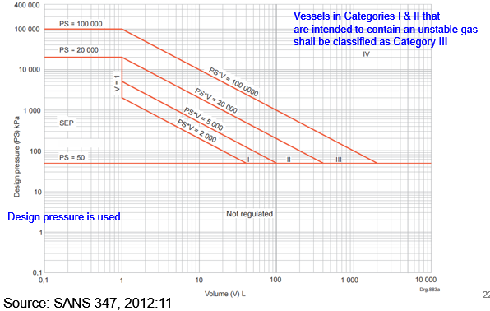
Figure 1: Design categorization of vessels containing dangerous gas

Vessels – Dangerous liquids
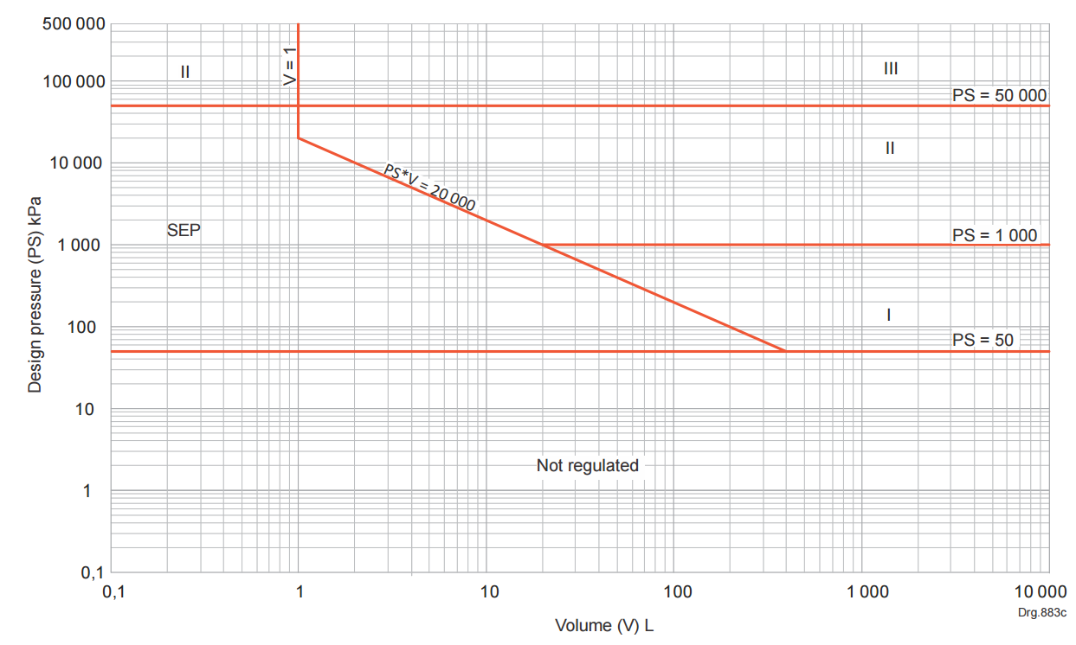
Source: (SANS 347, 2012)
Figure 2: Design categorization of vessels containing dangerous liquids

Piping – Dangerous gas
Similar graphs are available for piping of non-dangerous gas, dangerous liquids and non-dangerous liquids.
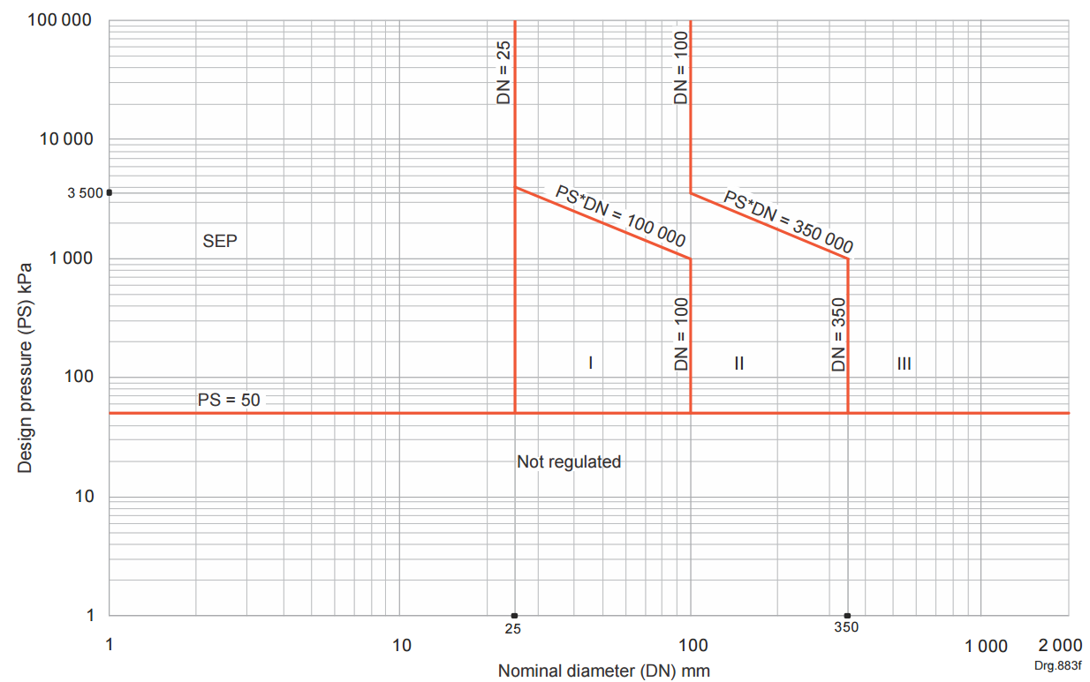
Source: (SANS 347, 2012, p. 16)

Transportable container and vessels for dangerous gas
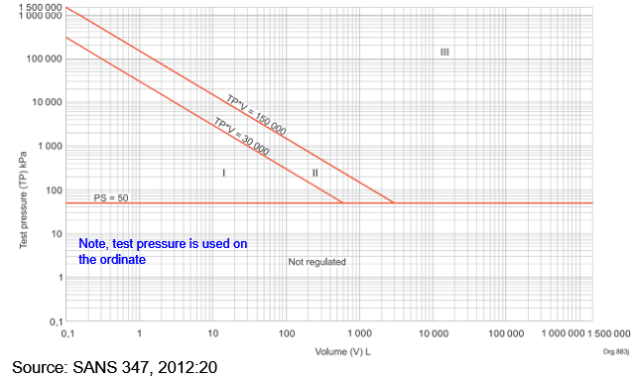

Vessels: Non-dangerous gas
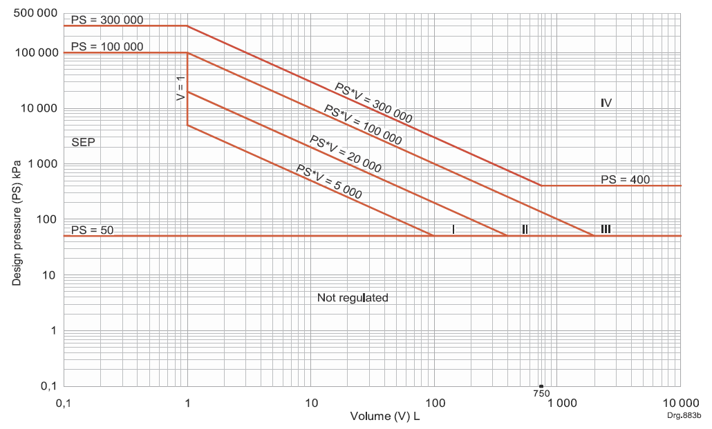
Source: (SANS 347, 2012, p. 12)
Figure 3: Design categorization of vessels: non-dangerous gas

